COMPUTER SYSTEMS VALIDATION EVIDENCE DOSSIER
Companion Screenshot Evidence & 21 CFR Part 11 Audit Trail
Protocol Document: | CLIN-EU-VAL-OPV-1-1-OQ-036
Protocol Version: | 1.0
Execution Timestamp: | 21-Oct-2026 (UTC)
Executed By: | sirihari.banda (CSV Automation Engine)
Compliance Standard: | 21 CFR Part 11 / EU Annex 11 Validated

Step TS1-S01: Accessing into Clinevo OnePV Intake Validation Environment.
Status: Pass | Observed: Login page displayed successfully.
Procedure: Open Browser.
Enter the validation URL
URL: https://val.one-aipv.com/login
Click on Enter (Keyboard operation).
(Refer expected result)
(((µ)))...
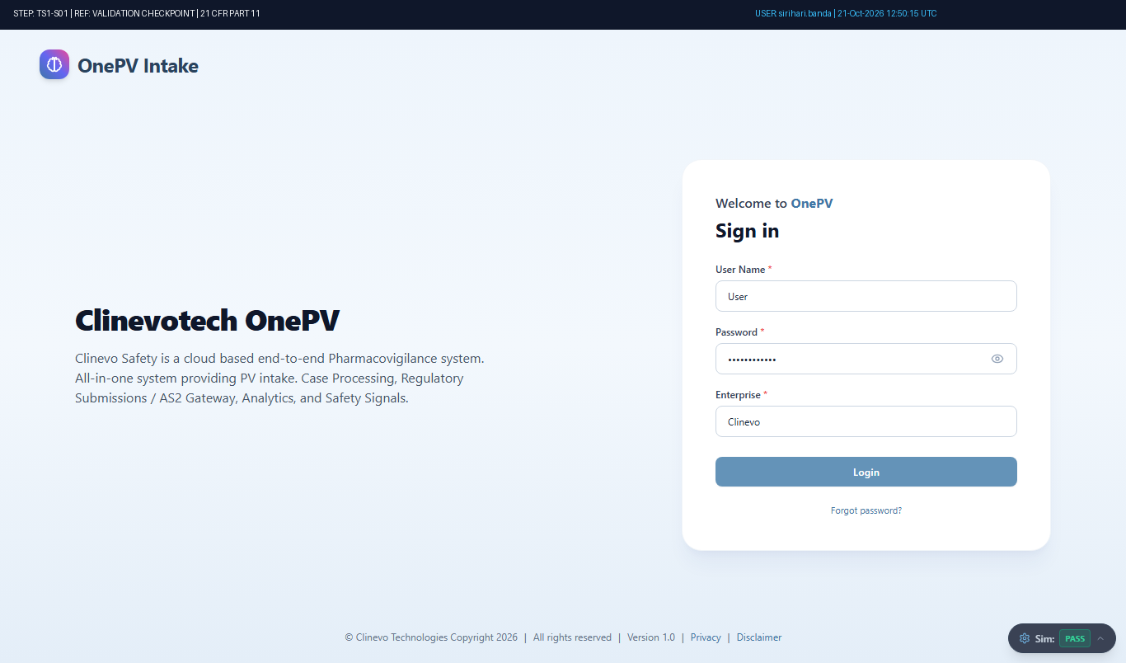
Figure: Audit-Stamped Evidence for TS1-S01 (Ref: TMP-CASE-6012)

Step TS1-S02: Login to Clinevo OnePV system
Status: Pass | Observed: Logged in as sirihari.banda. Header username and timestamp verified.
Procedure: Enter the following details in Login Page
User Name:
(Enter user name in text field)
Password:
(Enter the password)
Note: Enter the valid password for the user account at the runtime. User entered password at the runtime will be masked for securit...
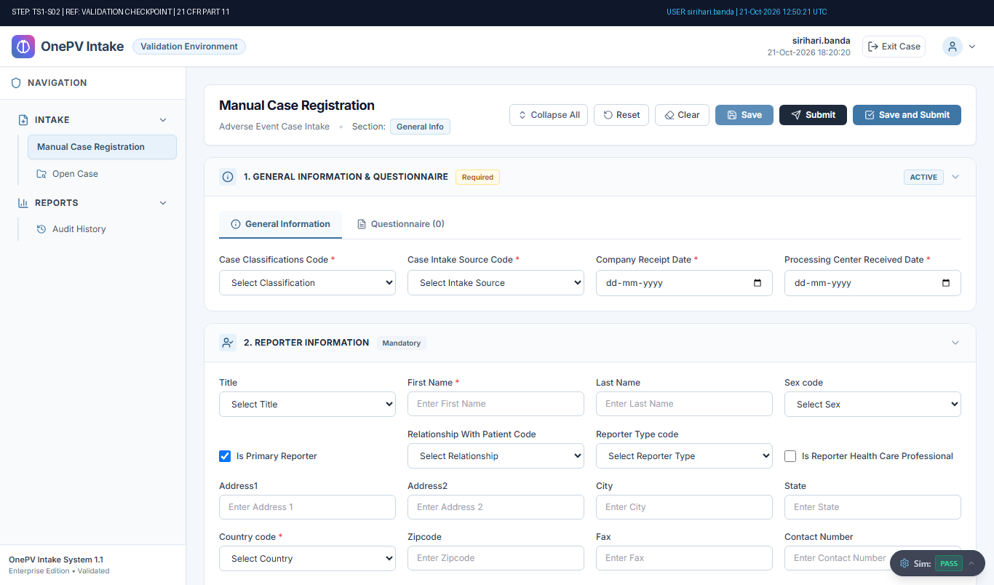
Figure: Audit-Stamped Evidence for TS1-S02 (Ref: TMP-CASE-6012)

Step TS1-S03: System shall allow to navigate Manual Case Registration page.
Status: Pass | Observed: Manual Case Registration form displayed with General Information and Intake sections.
Procedure: From left menu under Intake, Click on Manual Case Registration.
(Refer expected result)
(((µ)))...
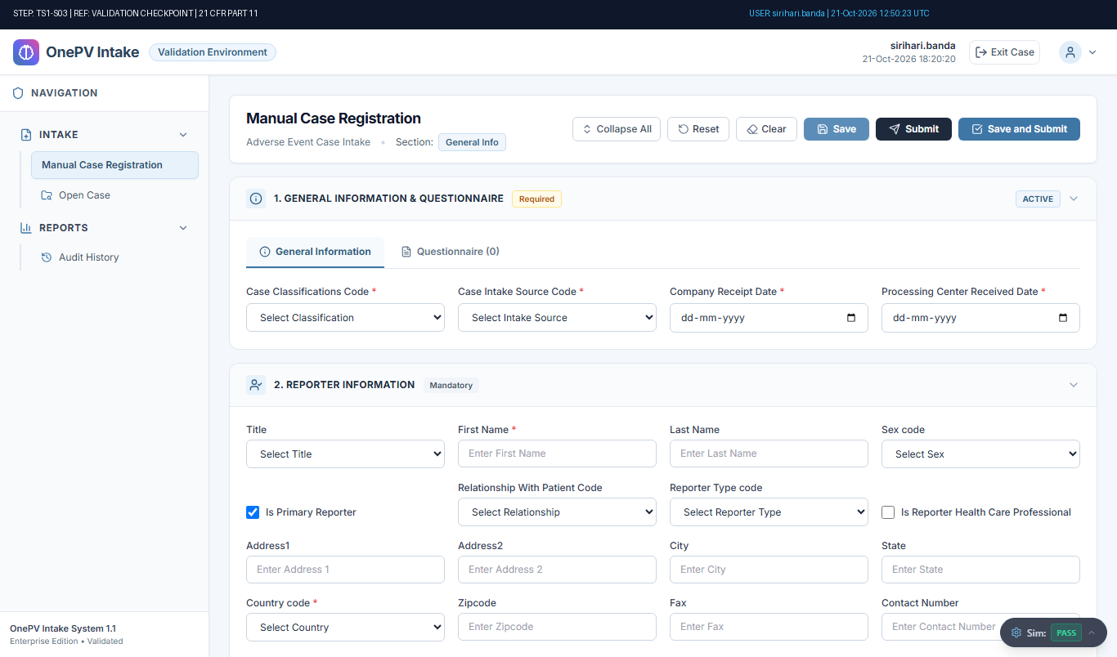
Figure: Audit-Stamped Evidence for TS1-S03 (Ref: TMP-CASE-6012)

Step TS1-S04: System shall not allow to submit case without entering data.
Status: Pass | Observed: System correctly displayed expected error message: Validation ErrorError: Cannot submit case without entering mandatory data.OK
Procedure: In Manual case registry page, without entering data in any field directly click on Submit button.
(Refer expected result)
(((µ)))
Click on OK button from validation message....
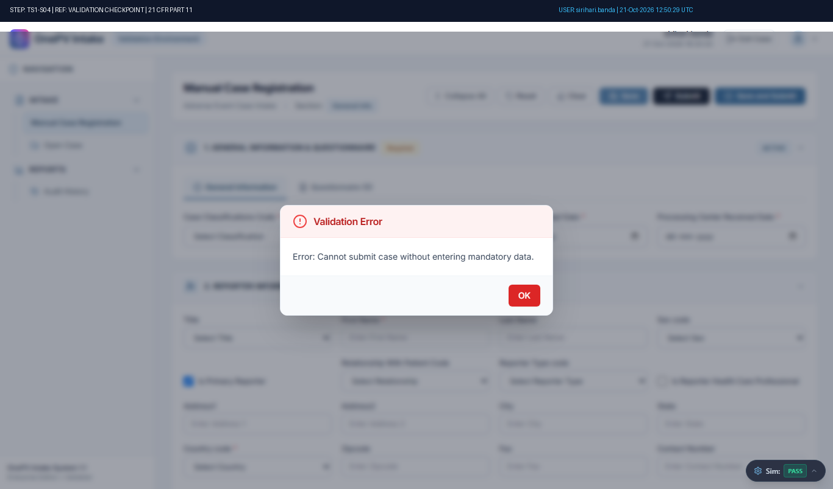
Figure: Audit-Stamped Evidence for TS1-S04 (Ref: TMP-CASE-6012)

Step TS1-S05: System shall not allow to register case, if following fields are empty.
Case Classifications Code
Case Intake Source Code
Company Receipt Date
Status: Pass | Observed: System correctly displayed expected validation error: Validation ErrorError: Case Intake Source Code and Company Receipt Date cannot be empty.OK
Procedure: In Manual Case Registry Page, under general info section enter the data in below fields,
Case Classifications Code:
(Unselect case classification)
Processing Center Received Date:
(Select the date from the calendar)
Click on the Save button.
(Ref...
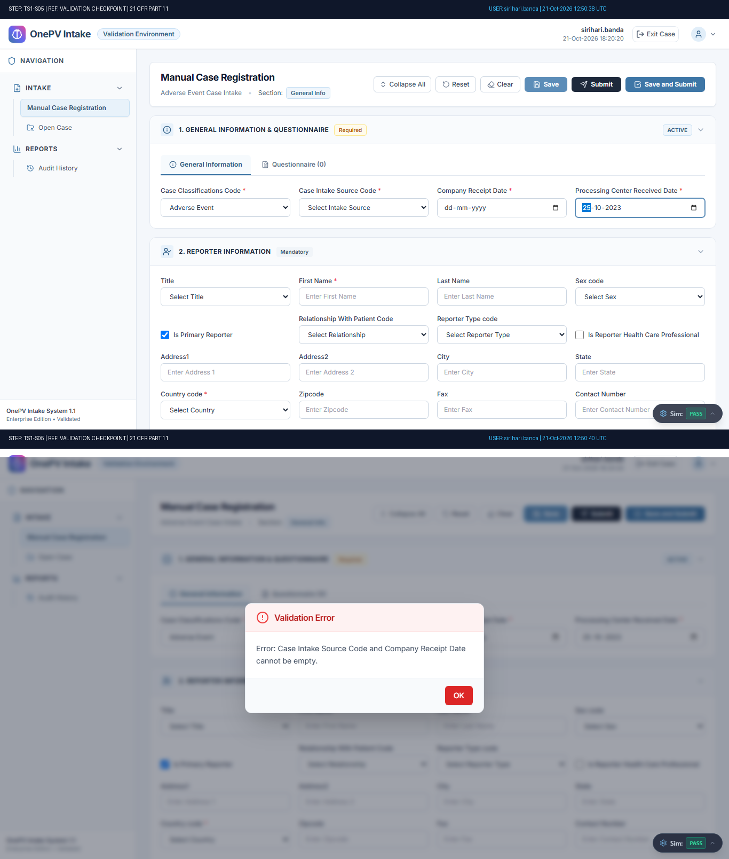
Figure: Audit-Stamped Evidence for TS1-S05 (Ref: TMP-CASE-6012)

Step TS1-S06: System shall not allow to register case, if following fields are empty.
Case Intake Source Code
Company Receipt Date
Status: Pass | Observed: System correctly displayed expected validation error: Validation ErrorError: Case Intake Source Code and Company Receipt Date cannot be empty.OK
Procedure: In register case section, under general info section enter the data in below fields,
Case Classifications Code: Adverse Event
(Select case classification from dropdown)
Processing Center Received Date:
(Select the date from th...
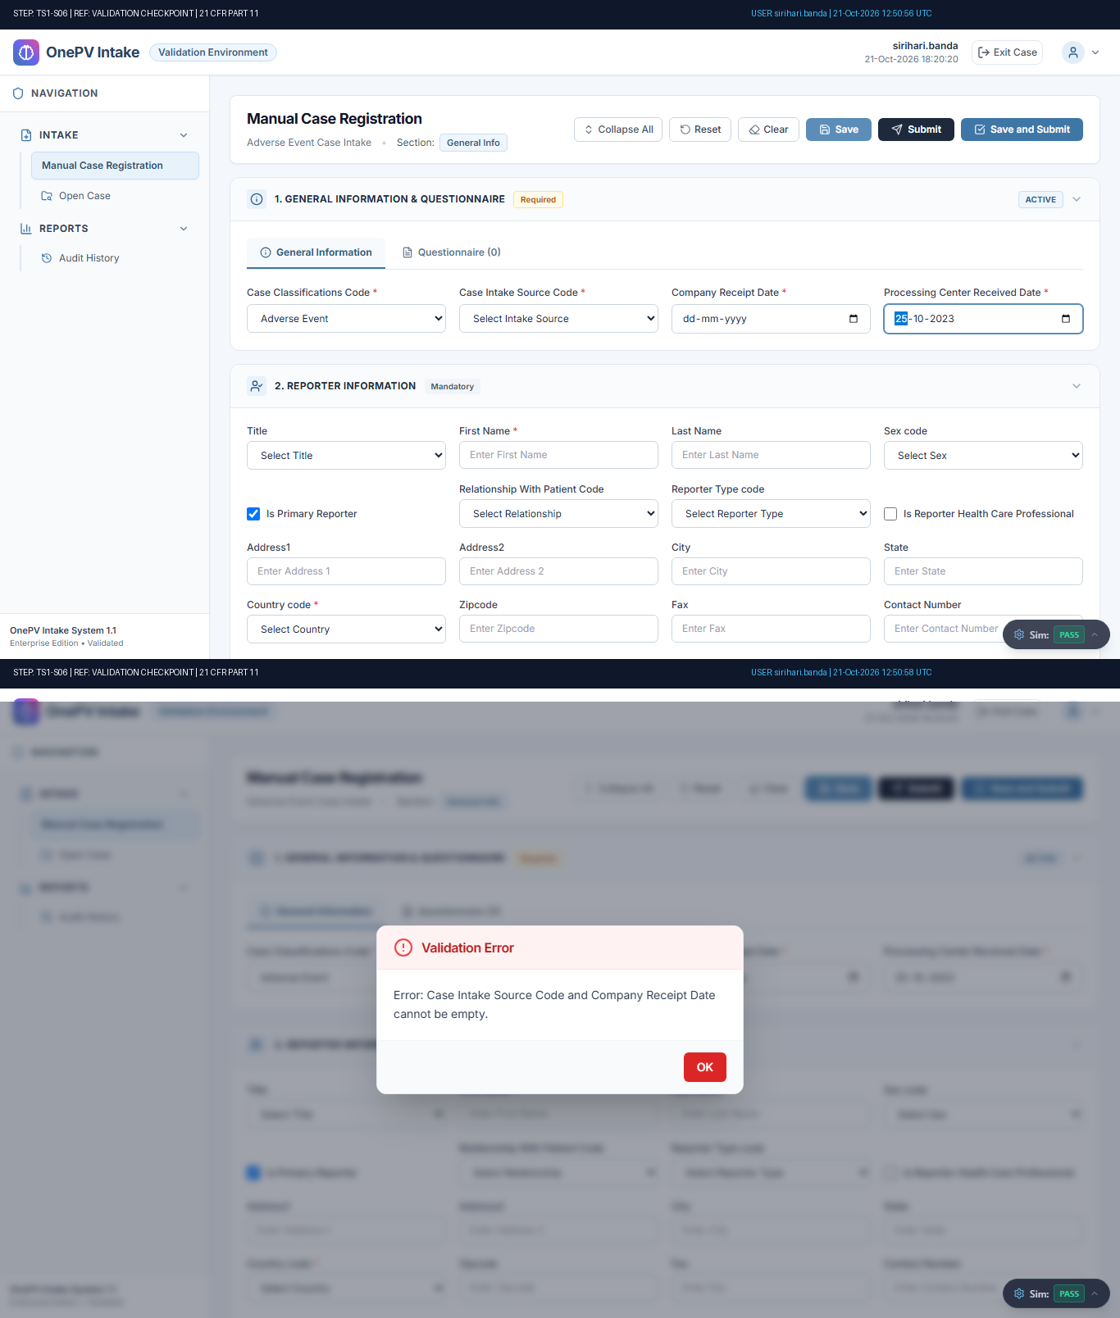
Figure: Audit-Stamped Evidence for TS1-S06 (Ref: TMP-CASE-6012)

Step TS1-S07: System shall not allow to register case, if following field is empty.
Company Receipt Date
Status: Pass | Observed: System correctly displayed expected validation error: Validation ErrorError: Company Receipt Date cannot be empty.OK
Procedure: In register case section, under general info section enter the data in below fields,
Case Classifications Code: Adverse Event
(Select case classification from dropdown)
Case Intake Source Code:
(Select from the dropdown)
Processing Cent...
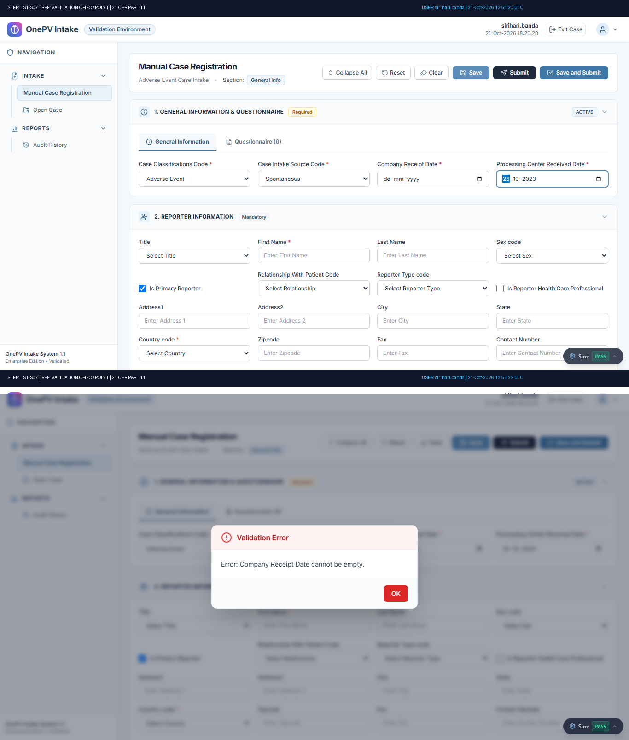
Figure: Audit-Stamped Evidence for TS1-S07 (Ref: TMP-CASE-6012)

Step TS1-S08: System shall not allow to register case, if Classifications doesn’t match.
Status: Fail | Observed: Discrepancy: Negative Test Discrepancy: Expected validation error was not displayed by the system. [Reviewer Acknowledged: Continued test execution]
Procedure: In Manual Case Registry Page, under general info section enter the data in below fields,
Case Classifications Code: General Inquiry
(Select case classification from dropdown)
Case Intake Source Code:
(Select from the dropdown)
Company R...
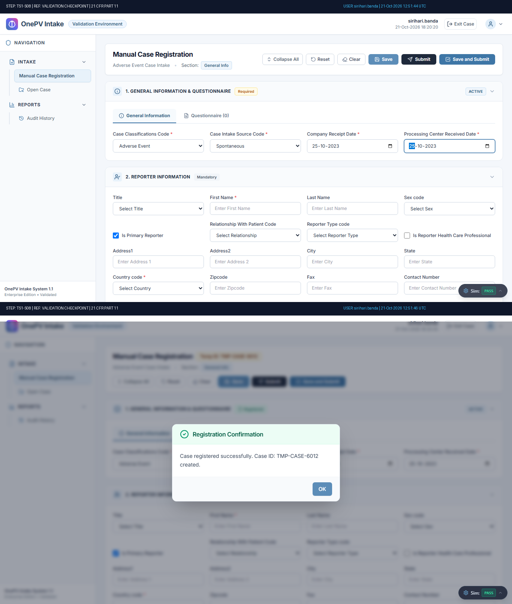
Figure: Audit-Stamped Evidence for TS1-S08 (Ref: TMP-CASE-6012)

Step TS1-S09: System shall allow to Register Case.
Status: Pass | Observed: Verified: System registered case successfully. Case ID TMP-CASE-6012 generated.
Procedure: In Manual Case Registry Page, under general info section enter the data in below fields,
Case Classifications Code: Adverse Event
(Select case classification from dropdown)
Case Intake Source Code:
(Select from the dropdown)
Company Rec...
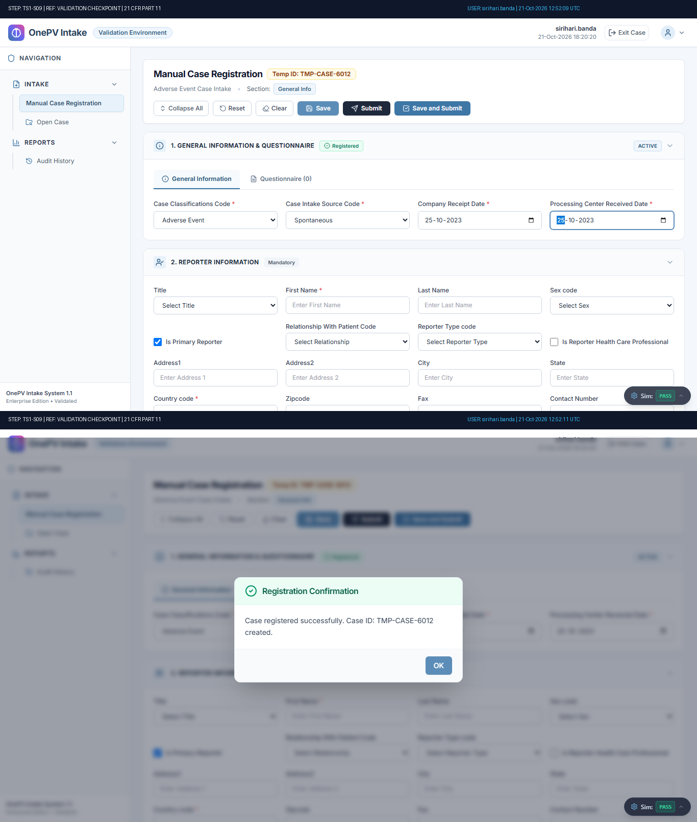
Figure: Audit-Stamped Evidence for TS1-S09 (Ref: TMP-CASE-6012)

Step TS1-S10: System shall not allow to add Questionnaire manually if mandatory fields are empty.
Status: Fail | Observed: Discrepancy: Negative Test Discrepancy: Expected validation error was not displayed by the system. [Reviewer Acknowledged: Continued test execution]
Procedure: Under General Info, from Questionnaire tab click on add questions button.
(Refer expected result 1)
In the pop-up, click on add questions manually radio button.
Click on the Save button.
(Refer expected result 2)
(((µ)))
Click on OK button....
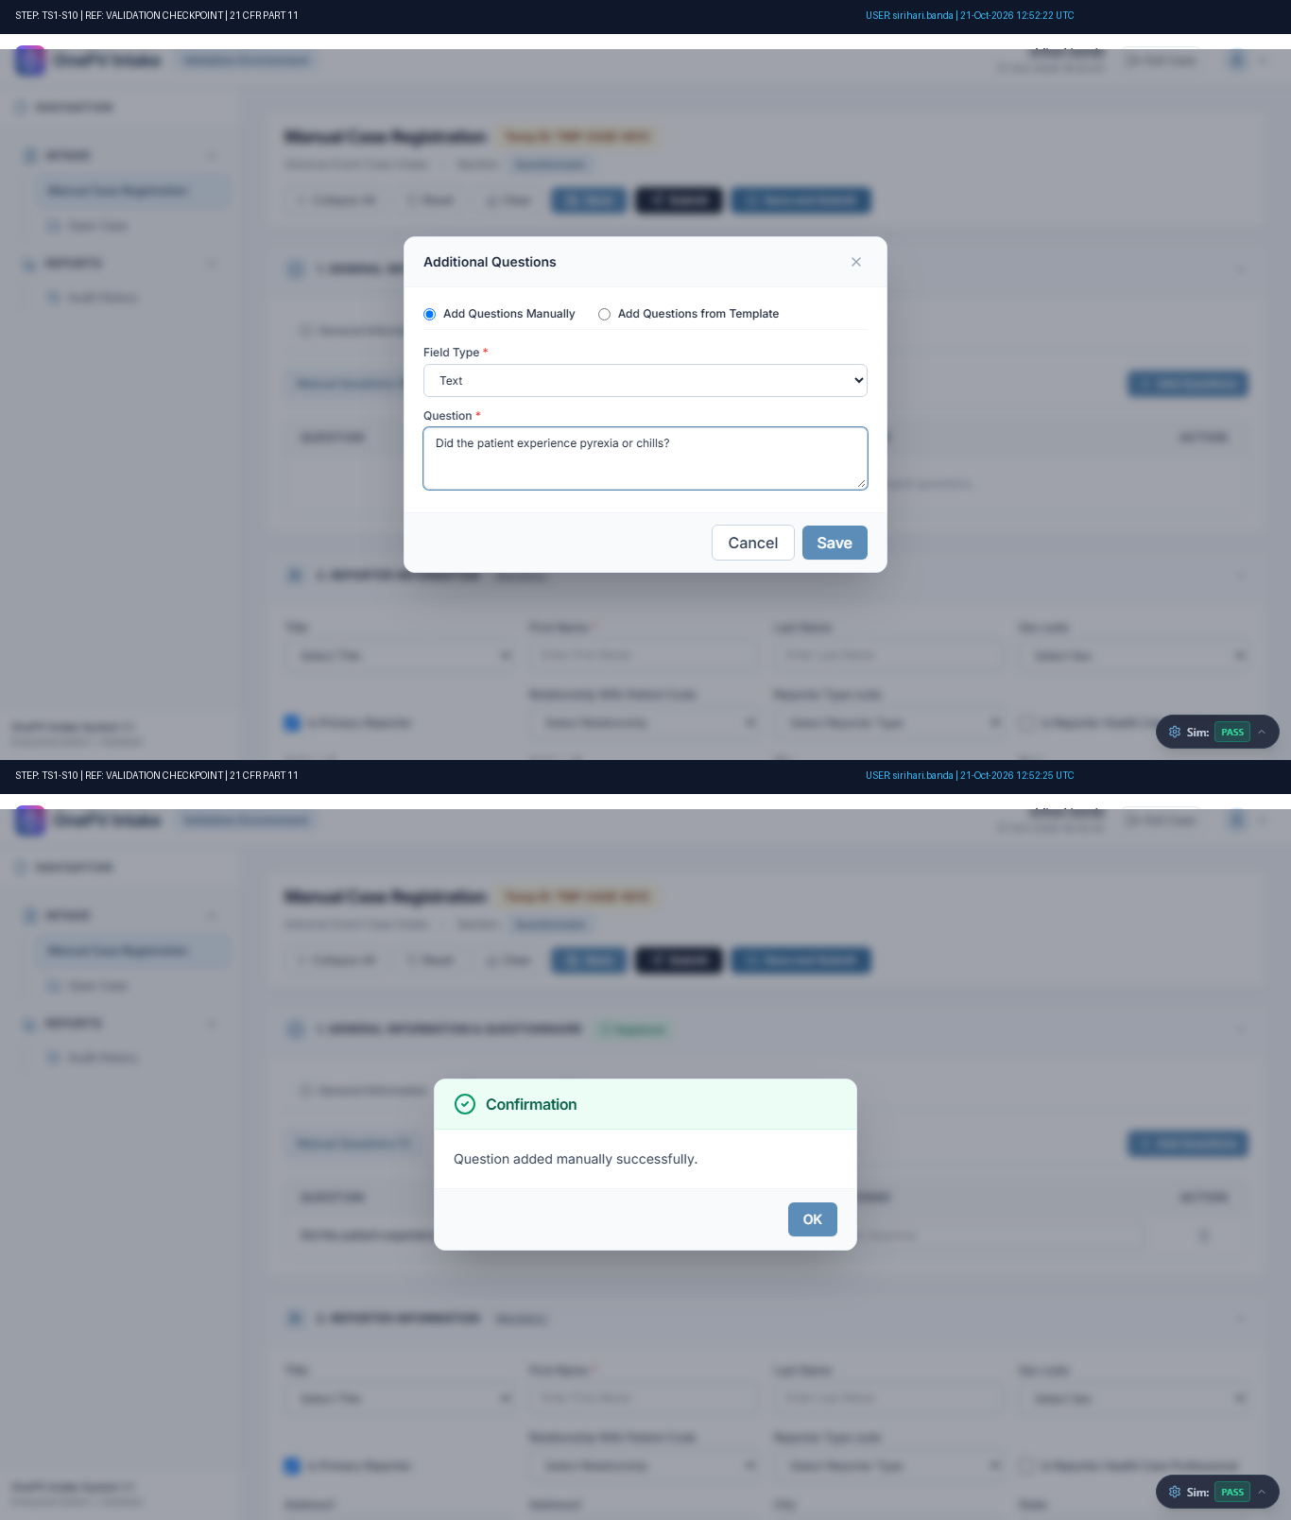
Figure: Audit-Stamped Evidence for TS1-S10 (Ref: TMP-CASE-6012)

Step TS1-S11: System shall allow to add Questionnaire manually
Status: Pass | Observed: Question added manually with confirmation message and displayed under Questionnaire tab.
Procedure: In Additional Question pop-up, enter the data in below fields,
Field Type:
(Select from the dropdown)
Question:
(Enter question in the text field)
Click on the Save button.
(Refer expected result)
(((µ)))
Click on OK button....
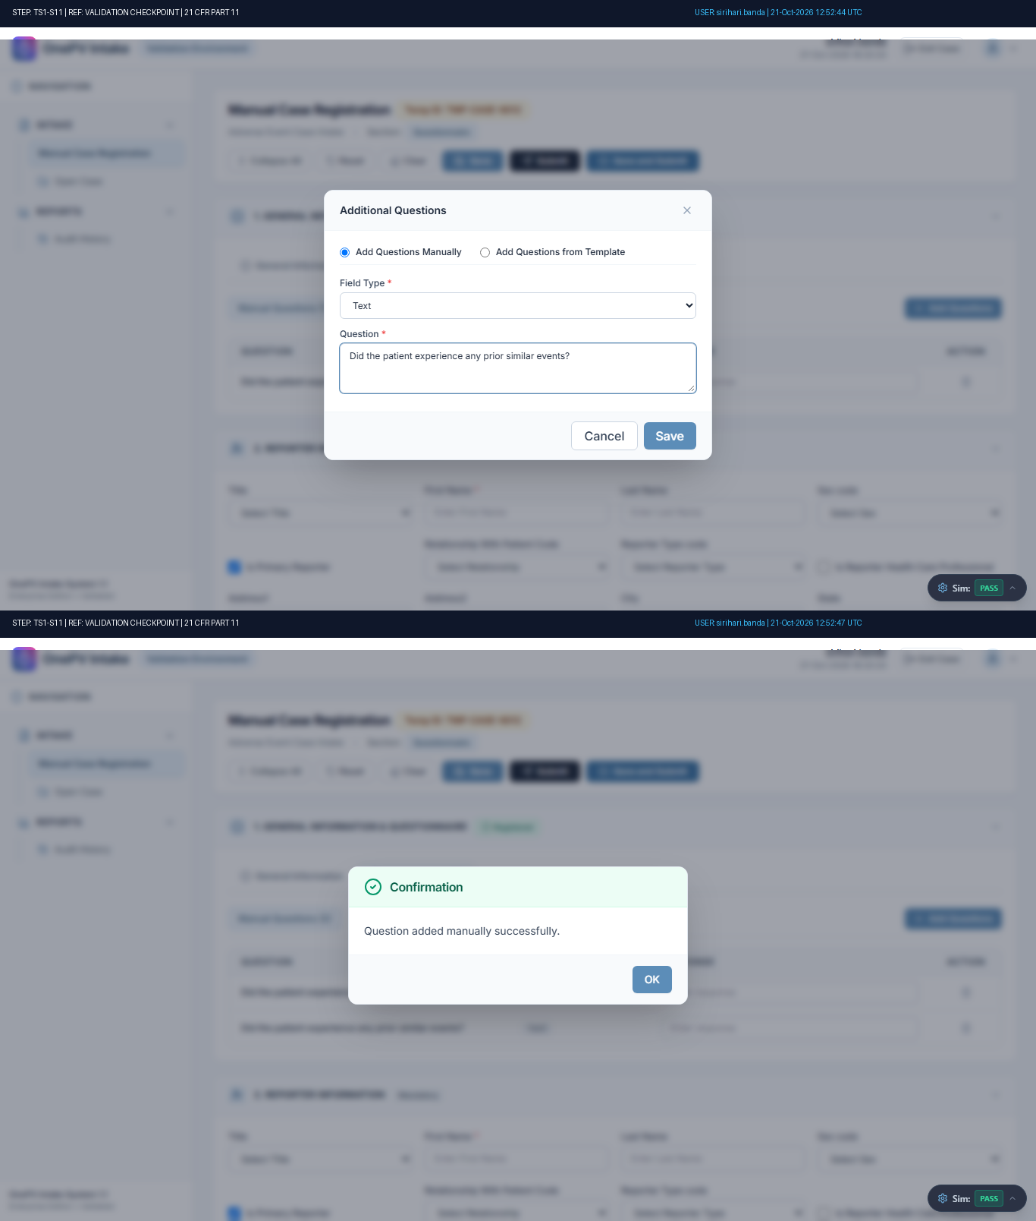
Figure: Audit-Stamped Evidence for TS1-S11 (Ref: TMP-CASE-6012)

Step TS1-S12: System shall allow to provide response for manually created question.
Status: Pass | Observed: Questionnaire response entered and saved successfully with confirmation message.
Procedure: Under response column, enter the response for the added questions.
Under Questionnaire tab, click on the Save button.
(Refer expected result)
(((µ)))
Click on OK button in the confirmation pop-up....
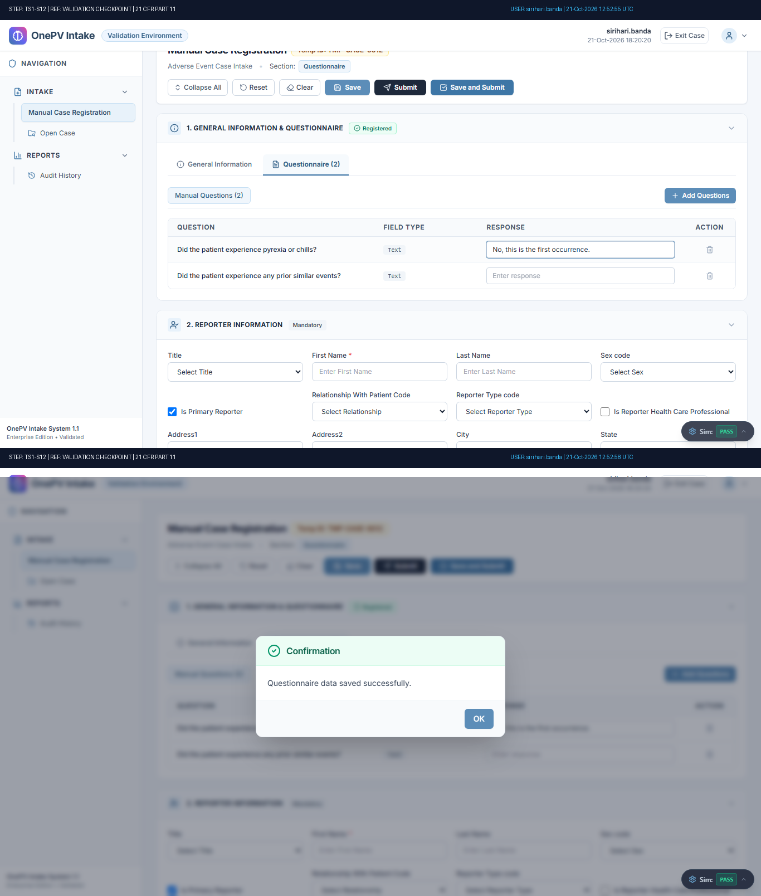
Figure: Audit-Stamped Evidence for TS1-S12 (Ref: TMP-CASE-6012)

Step TS1-S13: System shall allow to delete manually created questions.
Status: Fail | Observed: Discrepancy: Negative Test Discrepancy: Expected validation error was not displayed by the system. [Reviewer Acknowledged: Continued test execution]
Procedure: Under Questionnaire tab, click on the Delete icon.
Directly, Click on Delete button.
(Refer expected result 1)
Enter the Reason for delete.
Click on Delete button.
(Refer expected result 2)
(((µ)))...
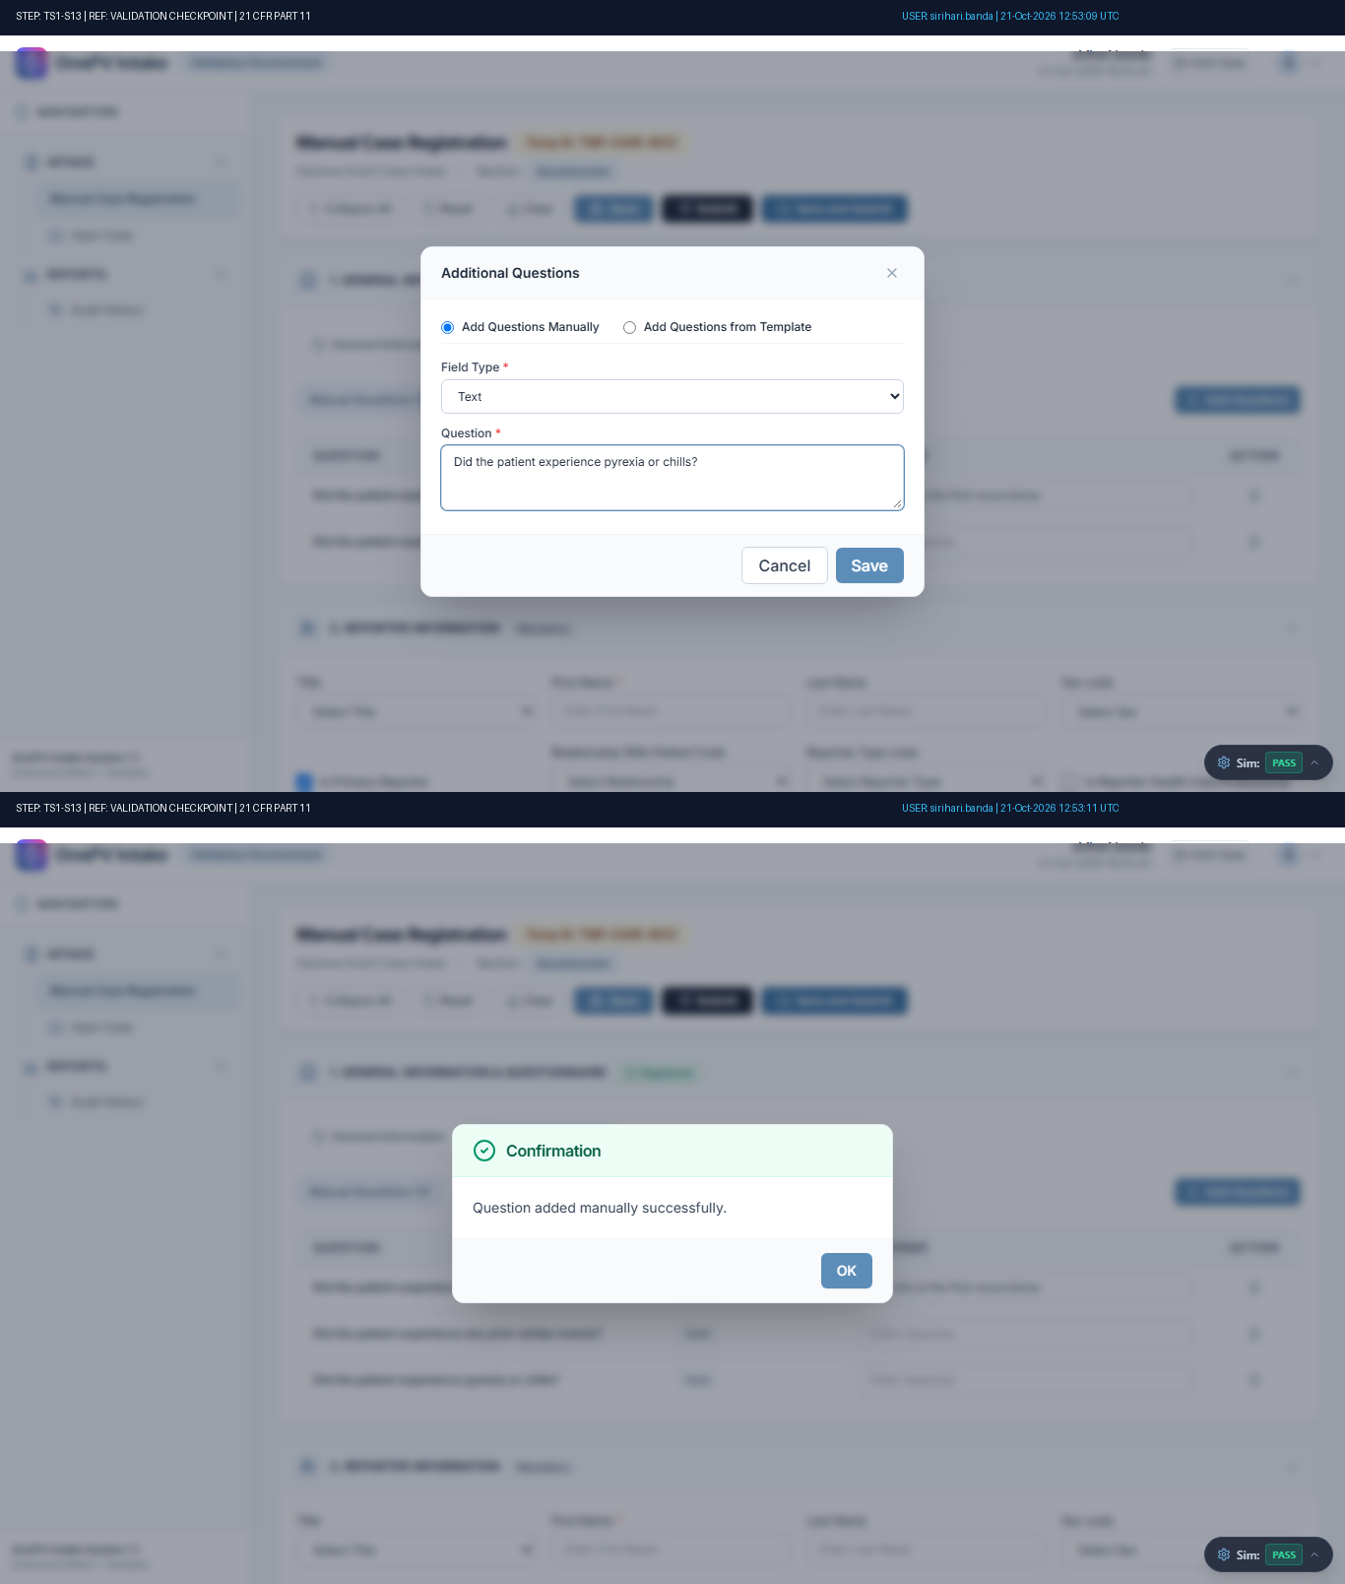
Figure: Audit-Stamped Evidence for TS1-S13 (Ref: TMP-CASE-6012)

Step TS1-S14: System shall allow to add Questionnaire from template.
Status: Pass | Observed: FAQ Template dialog selected and displayed.
Procedure: Under General Info, from Questionnaire tab click on add questions button.
(Refer expected result 1)
In the pop-up, click on add questions from template radio button and select template.
(Refer expected result 2)
Click on the Select button.
(Refer e...
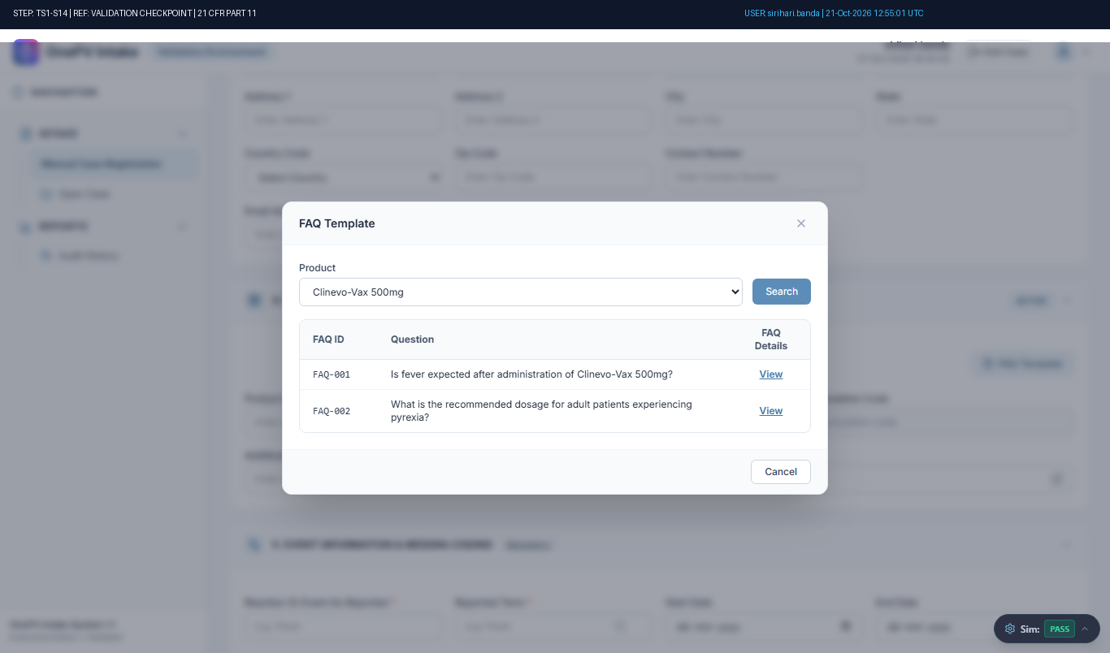
Figure: Audit-Stamped Evidence for TS1-S14 (Ref: TMP-CASE-6012)

Step TS1-S15: System shall allow to provide response for created question from template under Questionnaire tab.
Status: Pass | Observed: Template questionnaire response saved successfully.
Procedure: Under Questionnaire section in response column, enter the data for each question.
Under Questionnaire tab, click on the Save button.
(Refer expected result)
(((µ)))
Click on OK button in the confirmation pop-up....
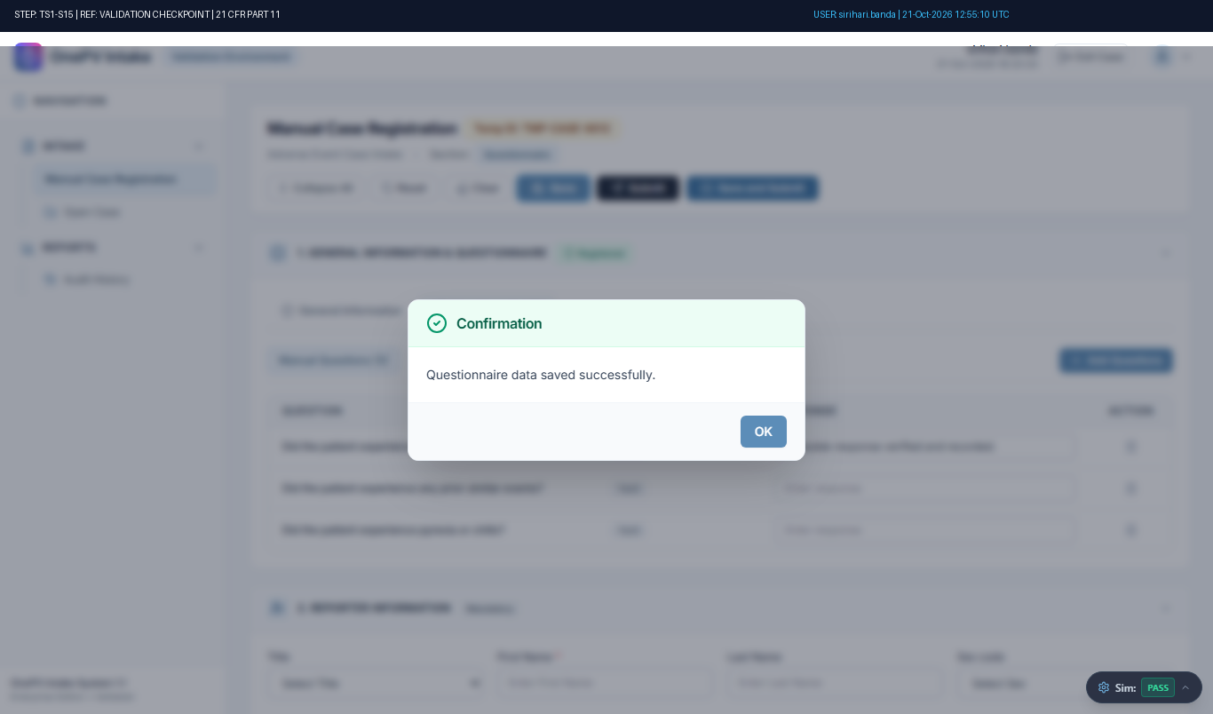
Figure: Audit-Stamped Evidence for TS1-S15 (Ref: TMP-CASE-6012)

Step TS1-S16: System shall allow to add one more Questionnaire from template.
Status: Pass | Observed: FAQ Template dialog selected and displayed.
Procedure: Under General Info, from Questionnaire tab click on add questions button.
(Refer expected result 1)
In the pop-up, click on add questions from template radio button and select template.
(Refer expected result 2)
Click on the Select button.
(Refer e...
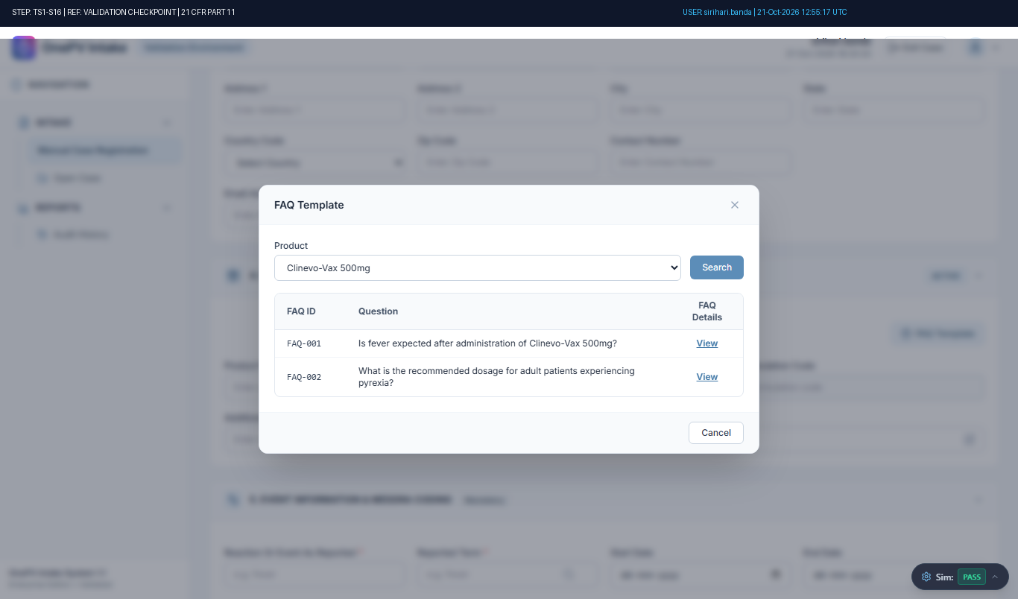
Figure: Audit-Stamped Evidence for TS1-S16 (Ref: TMP-CASE-6012)

Step TS1-S17: System shall restrict to import same Questionnaire template.
Status: Fail | Observed: Discrepancy: Negative Test Discrepancy: Expected validation error was not displayed by the system. [Reviewer Acknowledged: Continued test execution]
Procedure: Under General Info, from Questionnaire tab click on add questions button.
(Refer expected result 1)
In the pop-up, click on add questions from template radio button and select the previously selected template.
Click on the Select button.
(Refer exp...
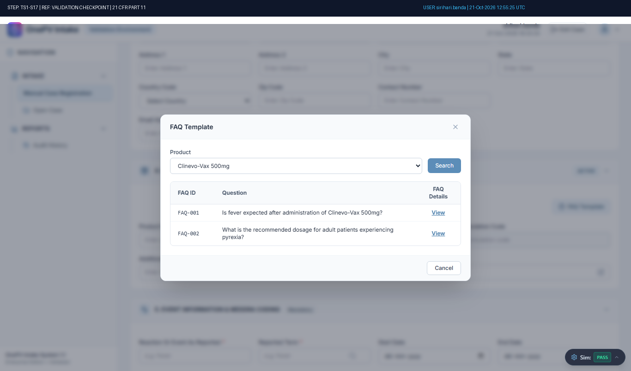
Figure: Audit-Stamped Evidence for TS1-S17 (Ref: TMP-CASE-6012)

Step TS1-S18: System shall allow to delete the Questionnaire template.
Status: Pass | Observed: FAQ Template dialog selected and displayed.
Procedure: Under Questionnaire in Questionnaire template Click on Delete icon.
Enter the Reason for delete and click on Delete button.
(Refer expected result)
(((µ)))...
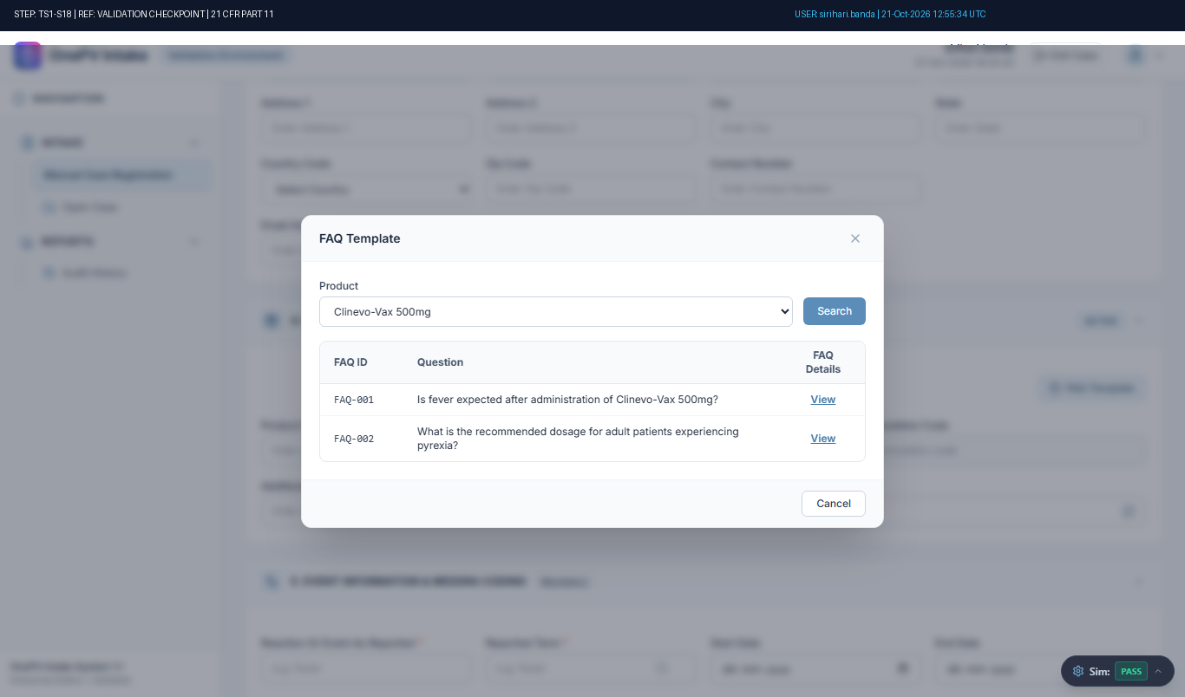
Figure: Audit-Stamped Evidence for TS1-S18 (Ref: TMP-CASE-6012)

Step TS1-S19: System shall not allow to Submit case if the Reporter Country and First Name is blank.
Status: Pass | Observed: System correctly displayed expected error message: Validation ErrorError: Reporter Country and First Name are mandatory to submit the case.OK
Procedure: In the Manual case registry page, enter the data in below fields,
Under Patient section enter below details:
First Name:
(Enter patient first name in text field)
Under Product Information section enter the below details
Product Name:
(Click ...
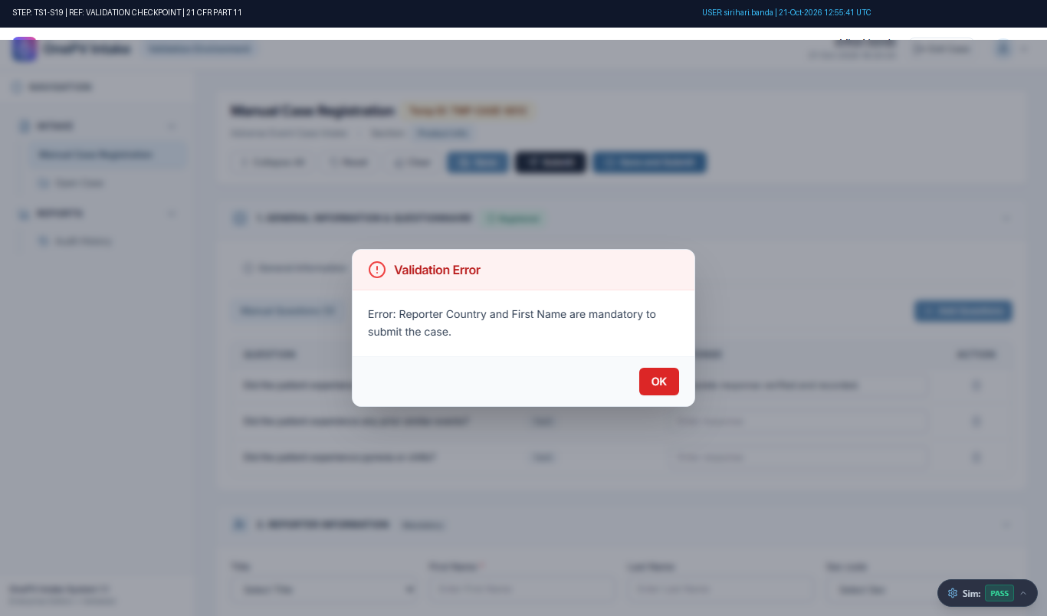
Figure: Audit-Stamped Evidence for TS1-S19 (Ref: TMP-CASE-6012)

Step TS1-S20: System shall not allow to Submit case if the Patient First Name is blank.
Status: Pass | Observed: System correctly displayed expected error message: Validation ErrorError: Reporter Country and First Name are mandatory to submit the case.OK
Procedure: In the Manual case registry page, enter the data in below fields,
Under Reporter section enter below details:
First Name:
(Enter reporter first name in text field)
Country Code:
(Select country from dropdown)
Under Product Informa...
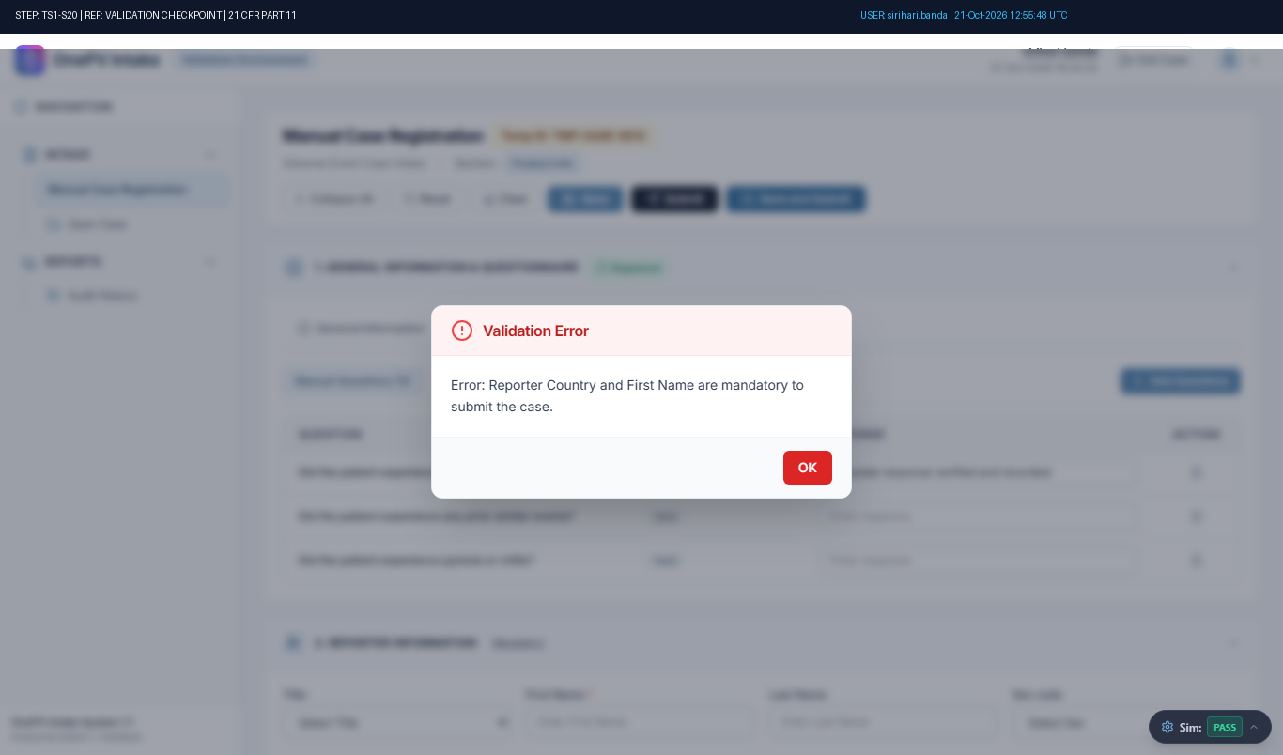
Figure: Audit-Stamped Evidence for TS1-S20 (Ref: TMP-CASE-6012)

Step TS1-S21: System shall not allow to Submit case if the product Name is blank
Status: Pass | Observed: System correctly displayed expected error message: Validation ErrorError: Reporter Country and First Name are mandatory to submit the case.OK
Procedure: In the Manual case registry page, enter the data in below fields,
Under Reporter section enter below details:
First Name:
(Enter reporter first name in text field)
Country Code:
(Select country from dropdown)
Under Patient section ...
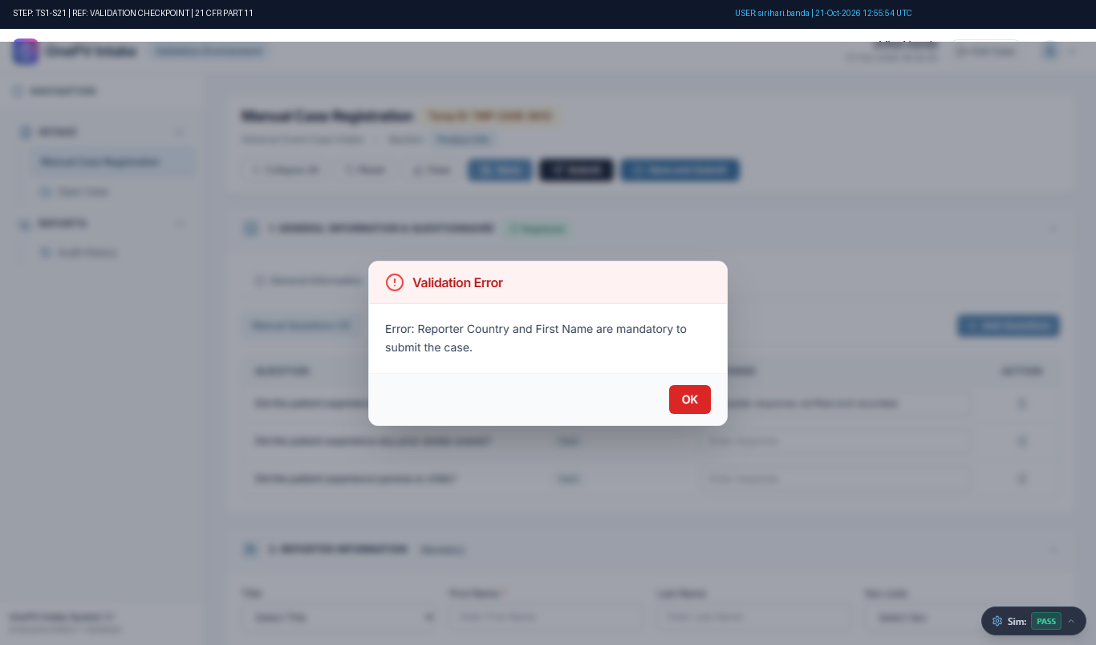
Figure: Audit-Stamped Evidence for TS1-S21 (Ref: TMP-CASE-6012)

Step TS1-S22: System shall not allow to Submit case if the Reaction Or Event As Reported and Reported Term is blank.
Status: Pass | Observed: System correctly displayed expected error message: Validation ErrorError: Reporter Country and First Name are mandatory to submit the case.OK
Procedure: In the Manual case registry page, enter the data in below fields,
Under Reporter section enter below details:
First Name:
(Enter reporter first name in text field)
Country Code:
(Select country from dropdown)
Under Patient section en...
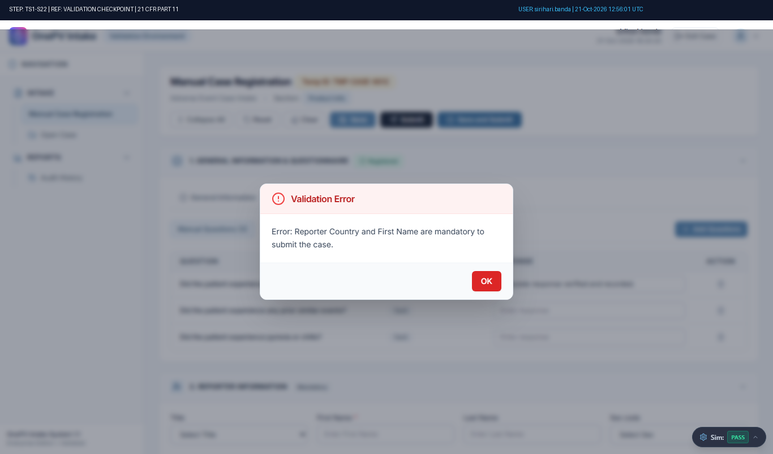
Figure: Audit-Stamped Evidence for TS1-S22 (Ref: TMP-CASE-6012)

Step TS1-S23: System shall allow to add reporter.
Status: Pass | Observed: Reporter information (16/16 fields) saved successfully with confirmation message.
Procedure: Under reporter section, enter below details:
Title
(Choose the value from dropdown)
First Name
(Enter the data)
Last Name
(Enter the data)
Sex code:
(Select from dropdown)
Is Primary Reporter:
(Don’t enable toggle button)
Relationship With P...
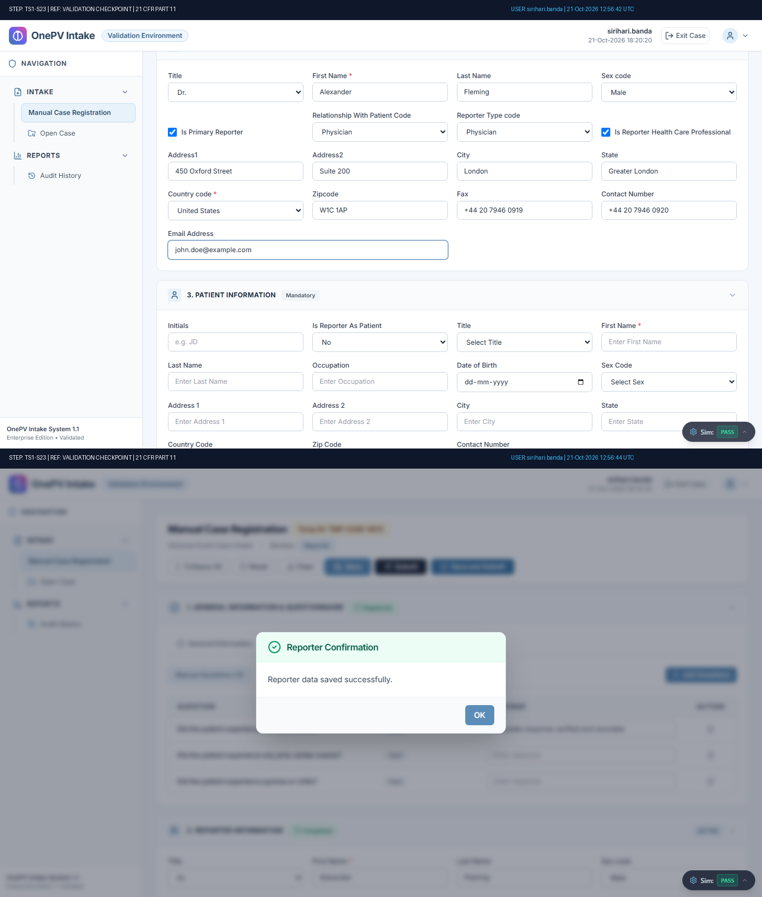
Figure: Audit-Stamped Evidence for TS1-S23 (Ref: TMP-CASE-6012)

Step TS1-S24: System shall allow to Update the reporter.
Status: Pass | Observed: Reporter information (16/16 fields) saved successfully with confirmation message.
Procedure: Under reporter section, Update the below details:
Title
(Update the value from dropdown)
First Name
(Update the data)
Last Name
(Update the data)
Sex code:
(Update the from dropdown)
Is Primary Reporter:
(Enable toggle button)
Relationship...
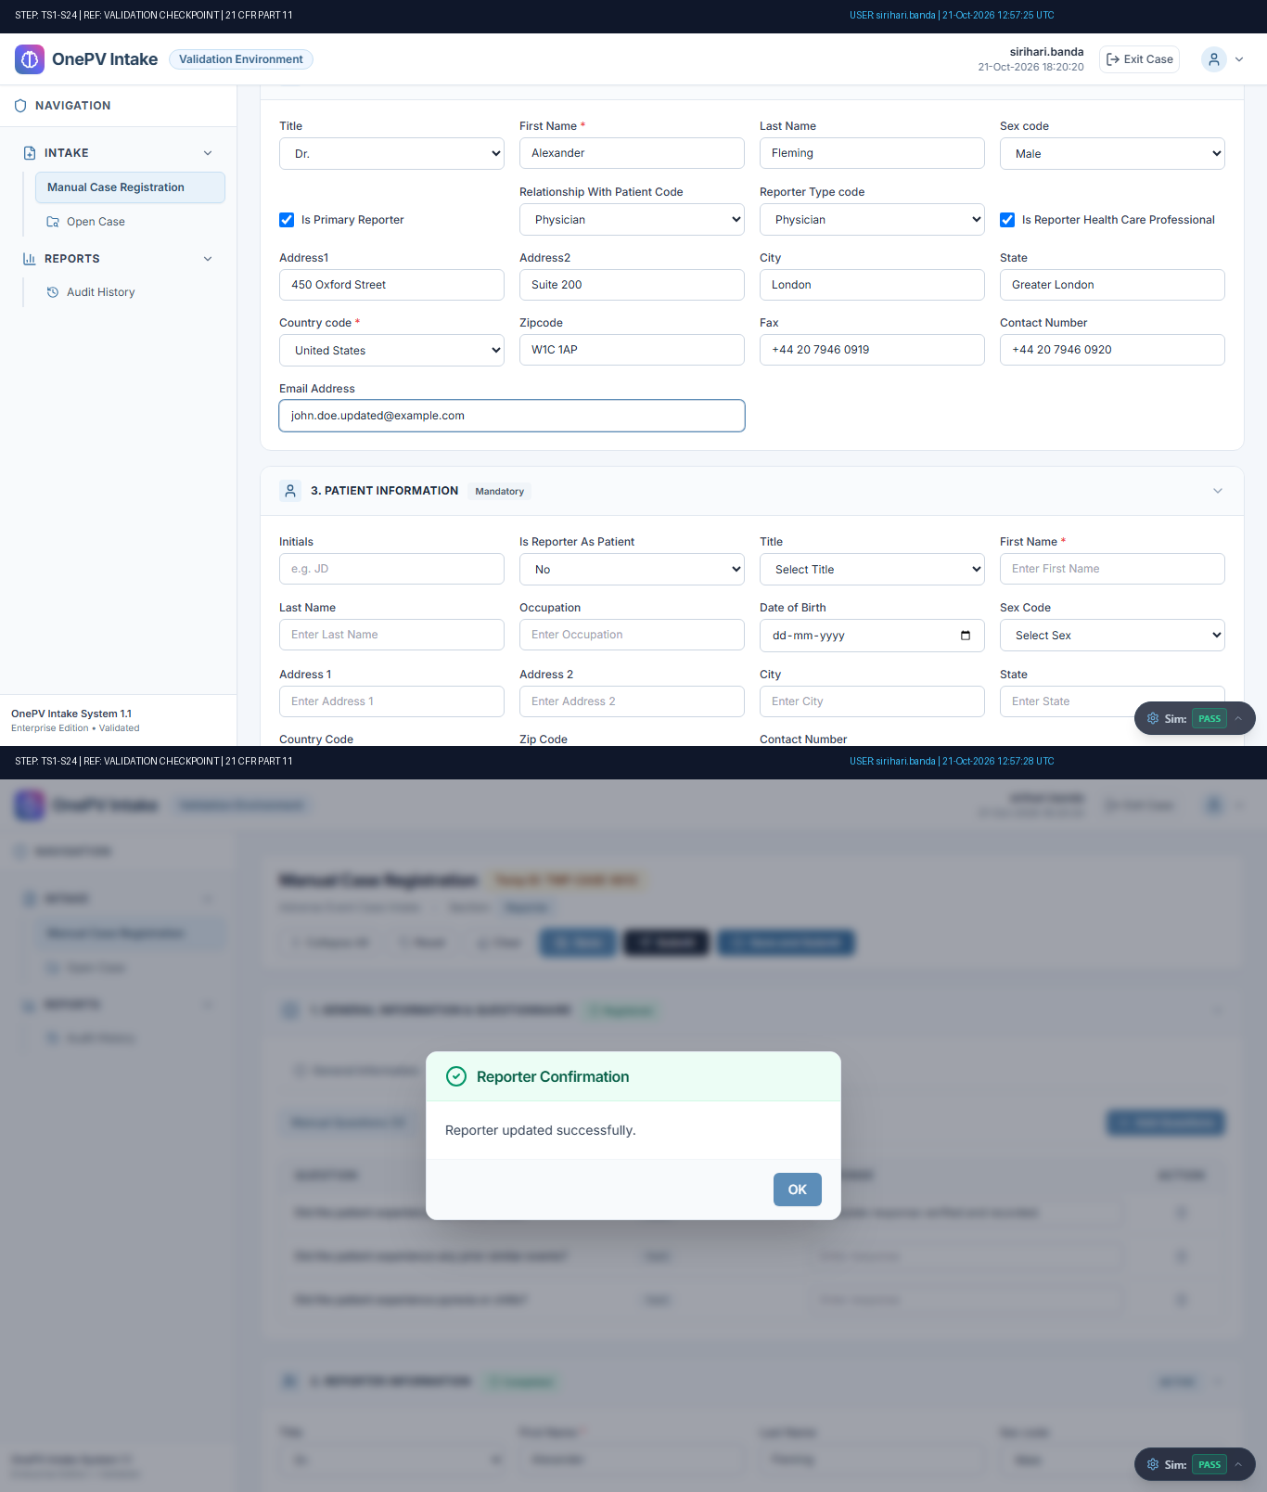
Figure: Audit-Stamped Evidence for TS1-S24 (Ref: TMP-CASE-6012)

Step TS1-S25: System shall allow to Add Patient information.
Status: Pass | Observed: Patient information (15/15 fields) saved successfully with confirmation message.
Procedure: Under Patient Information section enter the below details:
Initials
(Enter the data)
Is Reporter As Patient: No
(Select from the dropdown)
Title:
(Select from dropdown)
First Name
(Enter the data)
Last Name
(Enter ...
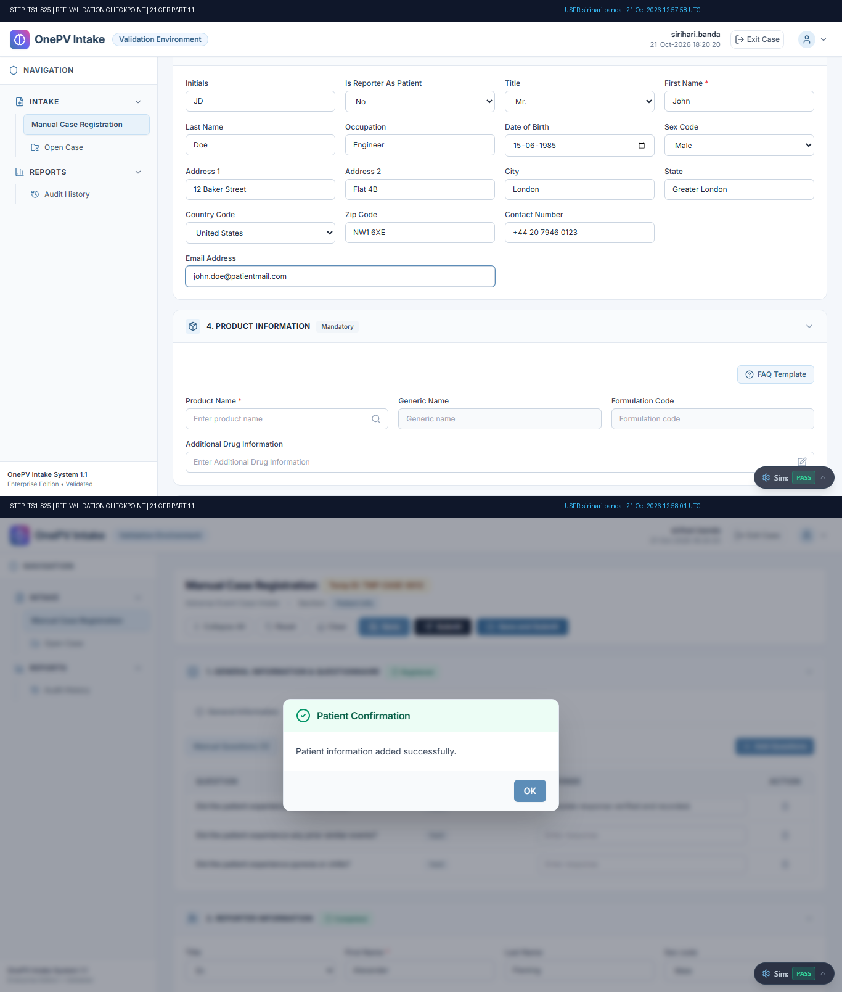
Figure: Audit-Stamped Evidence for TS1-S25 (Ref: TMP-CASE-6012)

Step TS1-S26: System shall allow to Update the Patient information.
Status: Pass | Observed: Patient information (15/15 fields) saved successfully with confirmation message.
Procedure: Under Patient Information Section Update the below details:
Initials
(Update the data)
Is Reporter As Patient: No
(Select from the dropdown)
Title:
(Update the from dropdown)
First Name
(Update the data)
Last Name
...
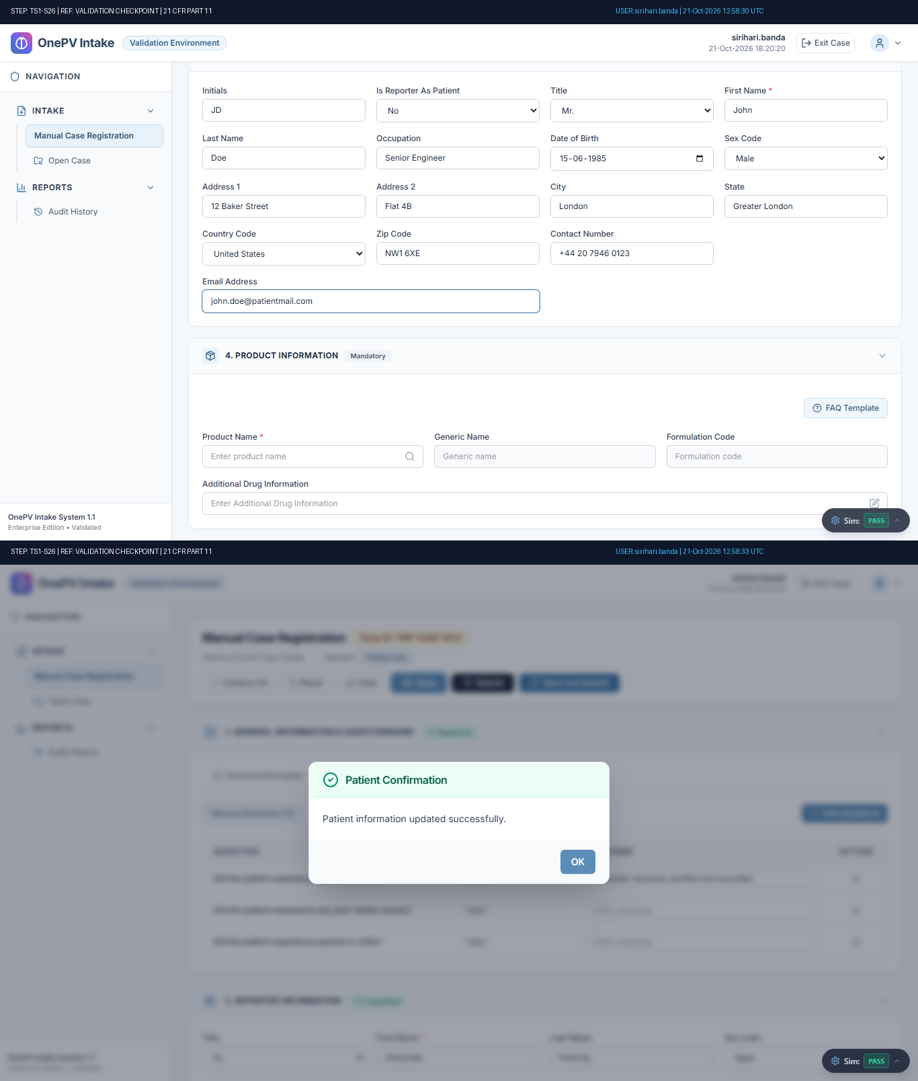
Figure: Audit-Stamped Evidence for TS1-S26 (Ref: TMP-CASE-6012)

Step TS1-S27: System shall allow to Add product.
Status: Pass | Observed: Product information added. Generic: 'Paracetamol', Formulation: 'TAB - Film-Coated Tablet' auto-populated.
Procedure: Under Product Information section enter the below details
Product Name:
(Click on the search icon and enter the product name in the search field. Select the product by click on the radio button and click on select button)
Additional Drug Informatio...
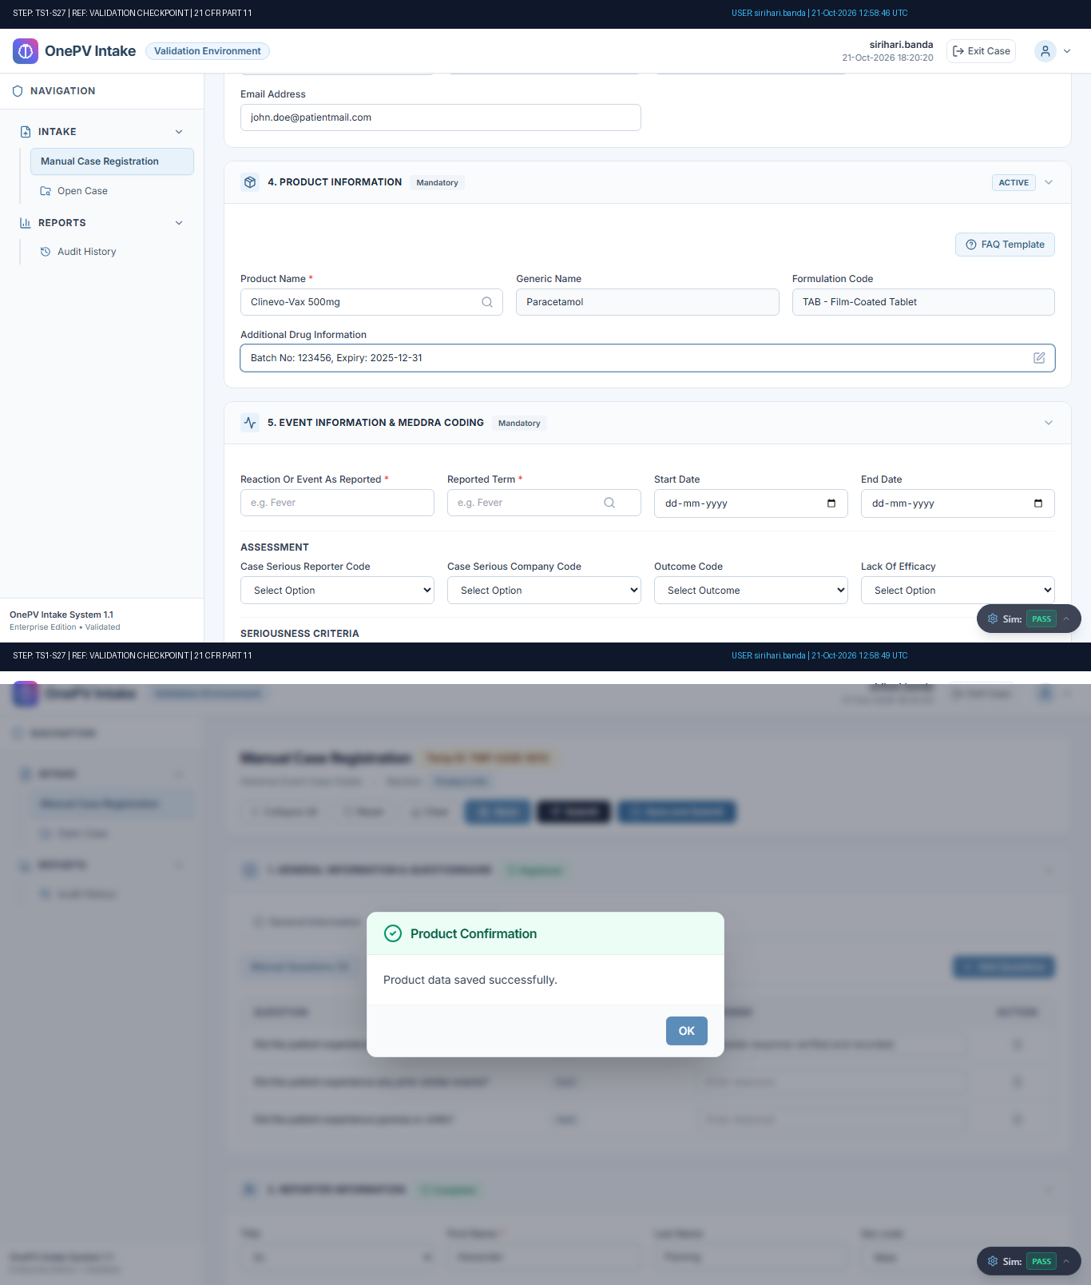
Figure: Audit-Stamped Evidence for TS1-S27 (Ref: TMP-CASE-6012)

Step TS1-S28: System shall Allow to view Product Information
Status: Pass | Observed: Product information added. Generic: 'Paracetamol', Formulation: 'TAB - Film-Coated Tablet' auto-populated.
Procedure: Click on Product Information hyper link.
(Refer expected result 1)
Click on the view hyperlink, under view column.
(Refer expected result 2)
(((µ)))
Close the opened tab....
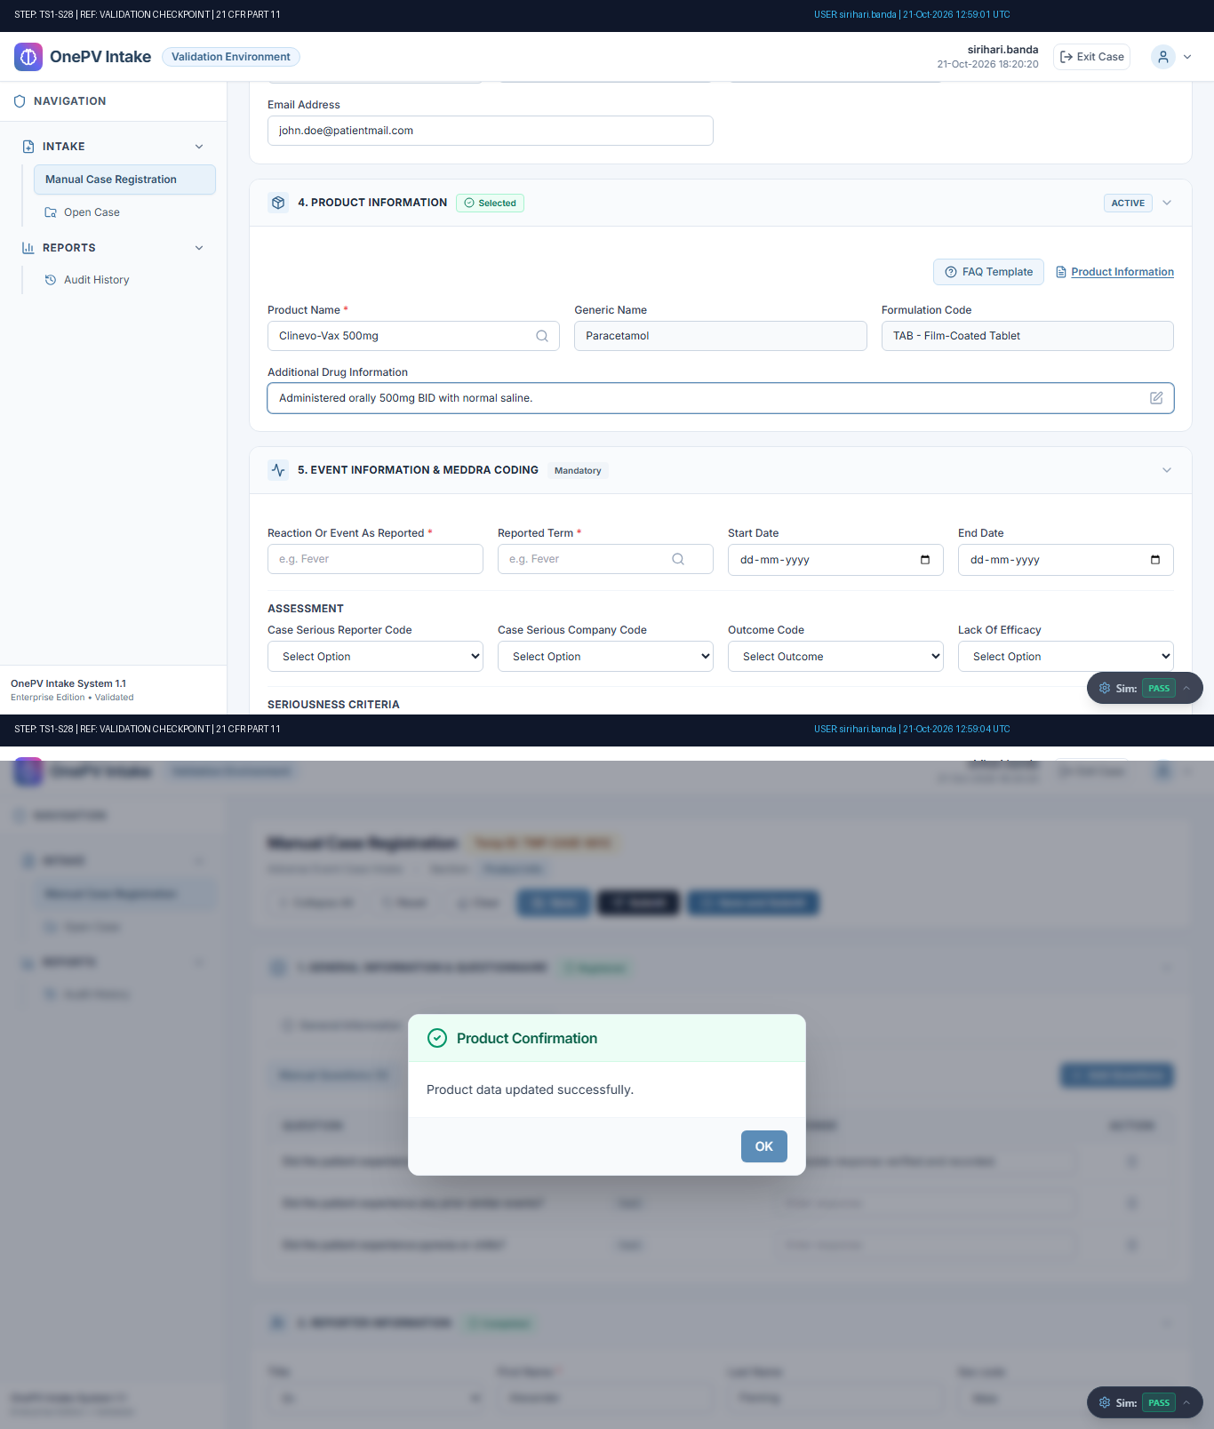
Figure: Audit-Stamped Evidence for TS1-S28 (Ref: TMP-CASE-6012)

Step TS1-S29: System shall Allow to download Product Information
Status: Pass | Observed: Product information added. Generic: 'Paracetamol', Formulation: 'TAB - Film-Coated Tablet' auto-populated.
Procedure: In the product medical information pop-up, click on the download icon, under download column.
(Refer expected result)
(((µ)))
Close the pop-up and....
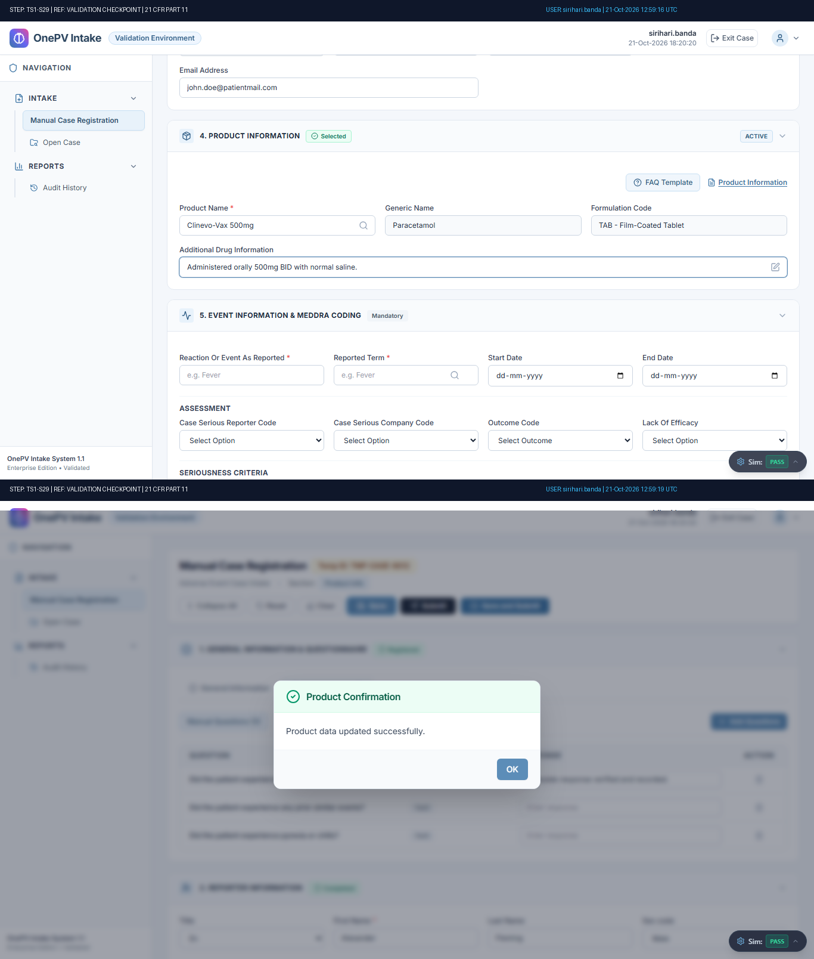
Figure: Audit-Stamped Evidence for TS1-S29 (Ref: TMP-CASE-6012)

Step TS1-S30: System shall allow to view FAQ during Initial case registration.
Status: Pass | Observed: Executed step action: GENERIC_ACTION
Procedure: Click on FAQ Template from product section.
In the FAQ Template pop-up, choose the Product from the dropdown.
Click on Search button.
(Refer expected result 1)
In the pop-up, for the respective question click on view hyperlink under the FA...
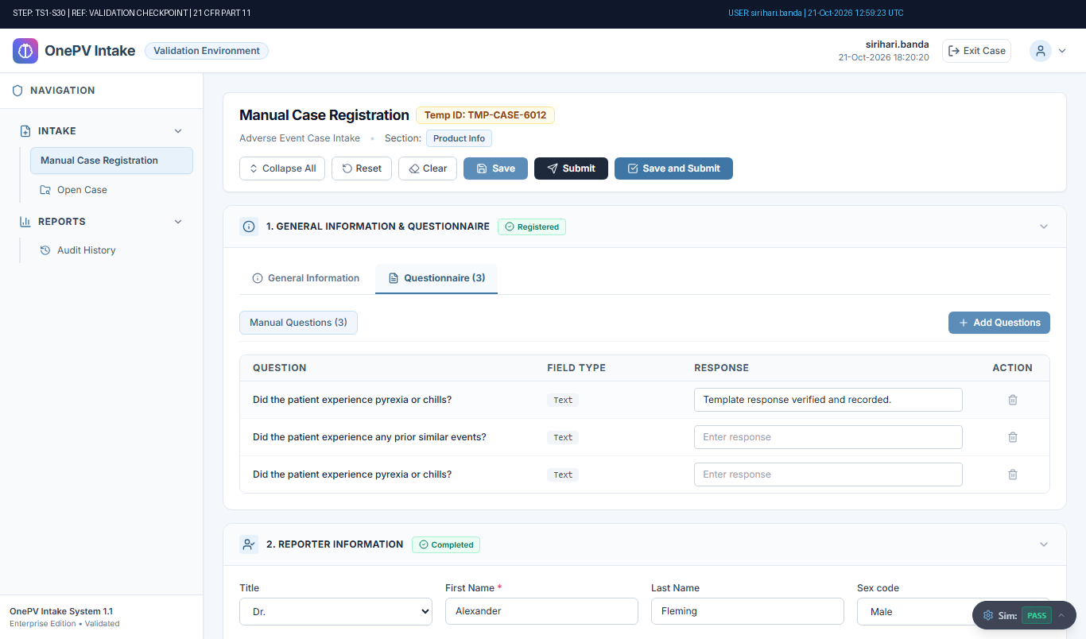
Figure: Audit-Stamped Evidence for TS1-S30 (Ref: TMP-CASE-6012)

Step TS1-S31: System shall allow to update the Additional Drug Information field data.
Status: Pass | Observed: Executed step action: GENERIC_ACTION
Procedure: Under Product information section, for Additional Drug Information field,
Click on edit icon, in the edit pop-up update the data for that field.
Click on OK button in the pop-up.
Click on Save button.
(Refer expected result)
(((µ)))...
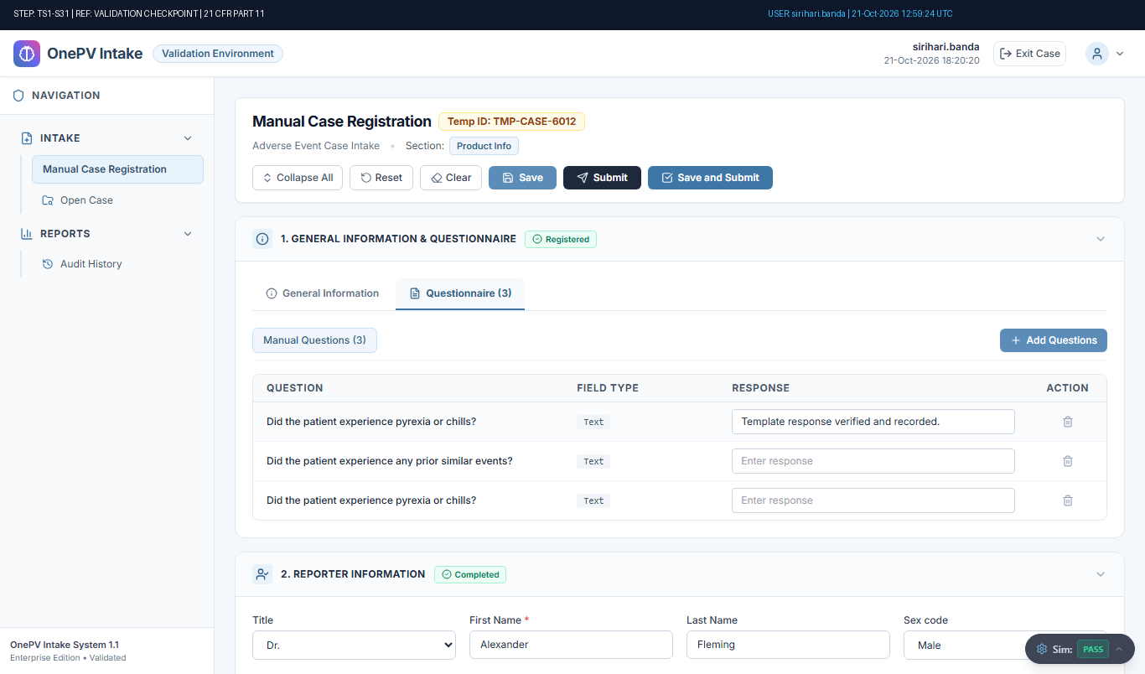
Figure: Audit-Stamped Evidence for TS1-S31 (Ref: TMP-CASE-6012)

Step TS1-S32: System shall allow to Add Event Information.
Status: Pass | Observed: MedDRA code 10019211 displayed and Event saved (4 assessment & 8 seriousness dropdowns verified).
Procedure: Under Event Information section, enter the data in below fields,
Reaction Or Event As Reported:
(Enter the data in the text field)
Reported Term:
(Enter term and click on the reported term search icon and select the meddra code)
(Refer expected r...
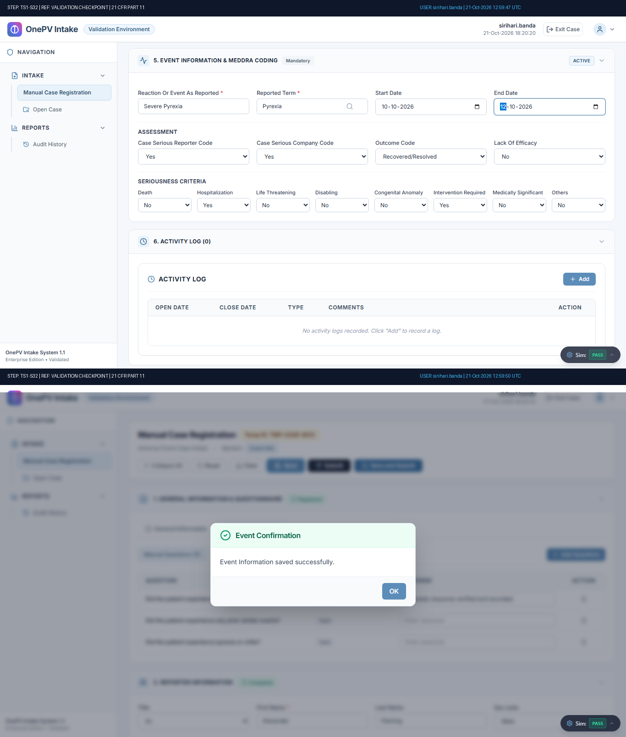
Figure: Audit-Stamped Evidence for TS1-S32 (Ref: TMP-CASE-6012)

Step TS1-S33: Verifying Reported Term’s Meddra Code.
Status: Pass | Observed: MedDRA code verified under Event Information tab.
Procedure: Navigate to Event Information tab.
Under Event Information, verify the Reported term meddra coded.
(Refer expected result)
(((µ)))...
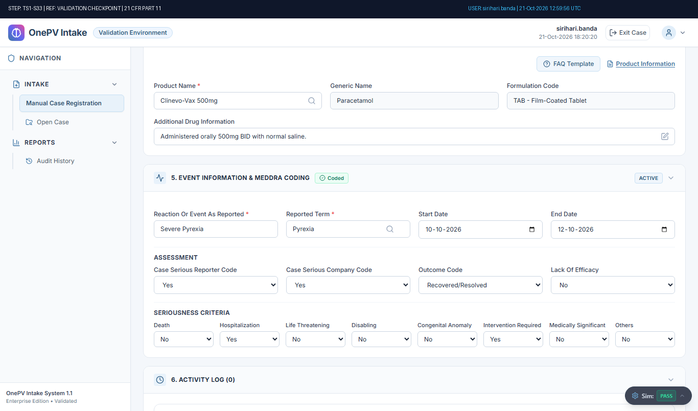
Figure: Audit-Stamped Evidence for TS1-S33 (Ref: TMP-CASE-6012)

Step TS1-S34: System shall allow to Update the Event Information.
Status: Pass | Observed: MedDRA code 10019211 displayed and Event saved (4 assessment & 8 seriousness dropdowns verified).
Procedure: Under Event Information section, Update the below fields:
Reaction Or Event As Reported:
(Update the data in the text field)
Reported Term:
(Update the term and click on search icon select meddra code)
(Refer expected result 1)
Start Date:
(Upda...
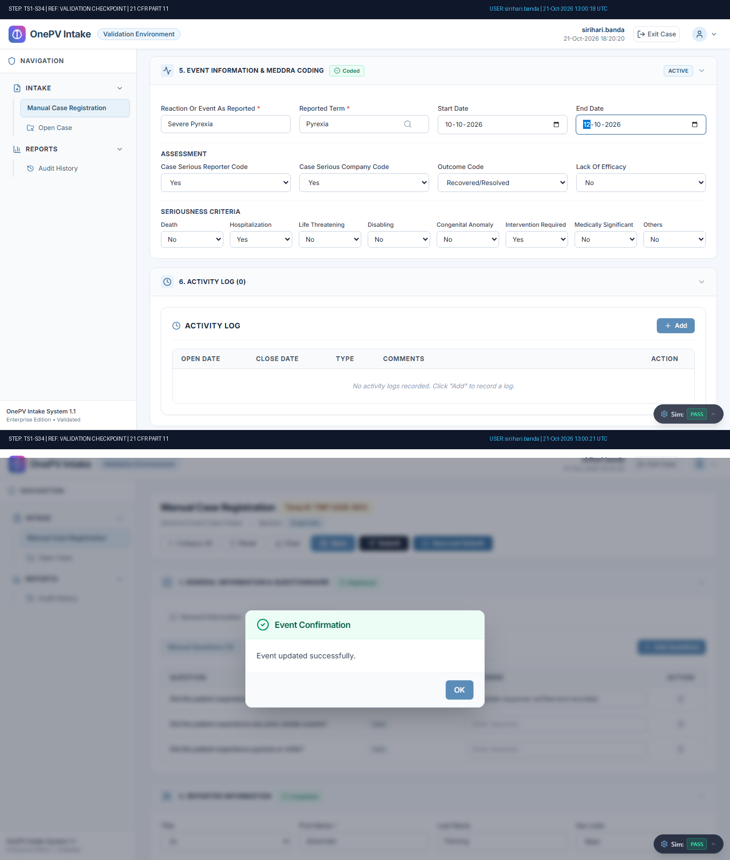
Figure: Audit-Stamped Evidence for TS1-S34 (Ref: TMP-CASE-6012)

Step TS1-S35: Verifying Updated Meddra Code.
Status: Pass | Observed: MedDRA code verified under Event Information tab.
Procedure: Navigate to Event Information tab.
Under Event Information, verify the Reported term meddra coded.
(Refer expected result)
(((µ)))...
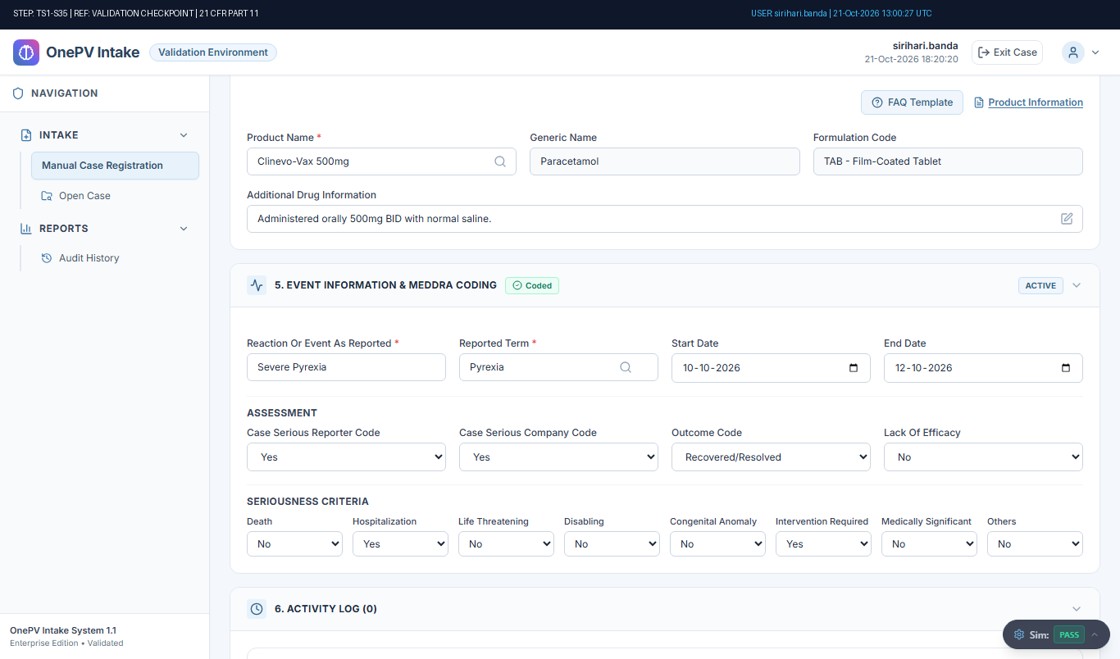
Figure: Audit-Stamped Evidence for TS1-S35 (Ref: TMP-CASE-6012)

Step TS1-S36: System shall allow to add Log details.
Status: Pass | Observed: Activity log added successfully with confirmation.
Procedure: Under activity log, click on add button enter below details,
Open Date:
(Select date)
Close Date:
(Select date)
Type:
(Select type from dropdown)
Comments:
(Enter comment)
Click on Save button.
(Refer expected result)
(((µ)))
Click o...
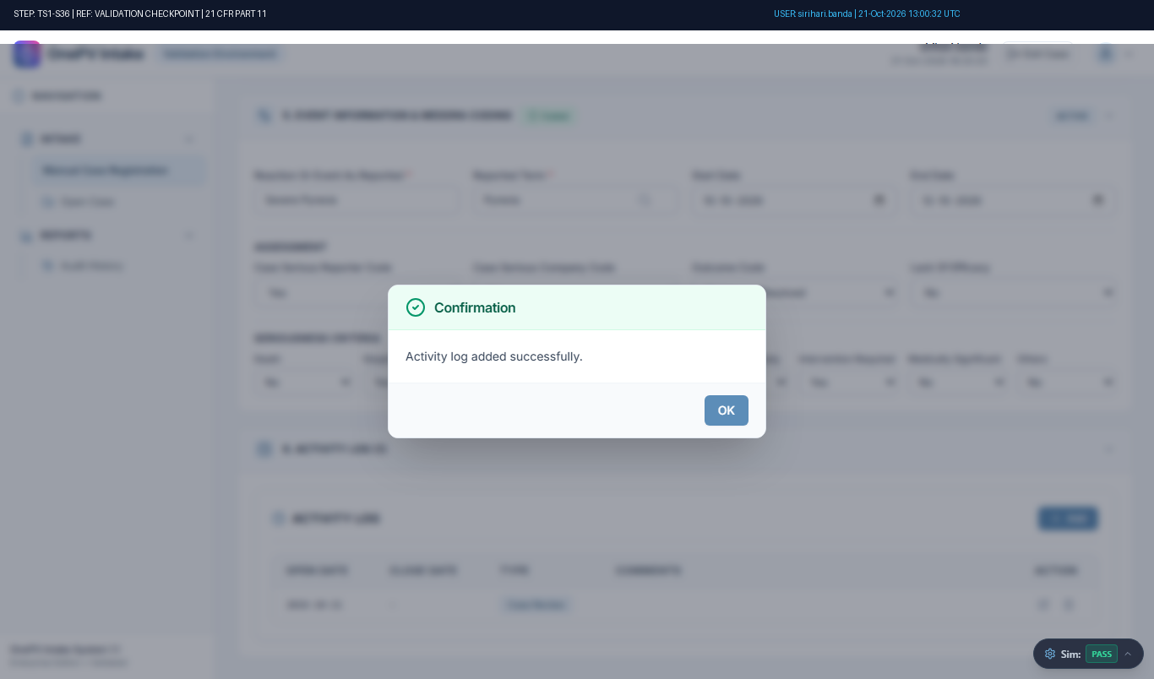
Figure: Audit-Stamped Evidence for TS1-S36 (Ref: TMP-CASE-6012)

Step TS1-S37: System shall allow to Update the Log detail.
Status: Pass | Observed: Activity log added successfully with confirmation.
Procedure: Under activity log, click on edit icon for newly created record and update the below fields,
Open Date:
(Update the open date)
Close Date:
(Update the close date)
Type:
(Select type from dropdown)
Comments:
(Update the comment)
Click o...
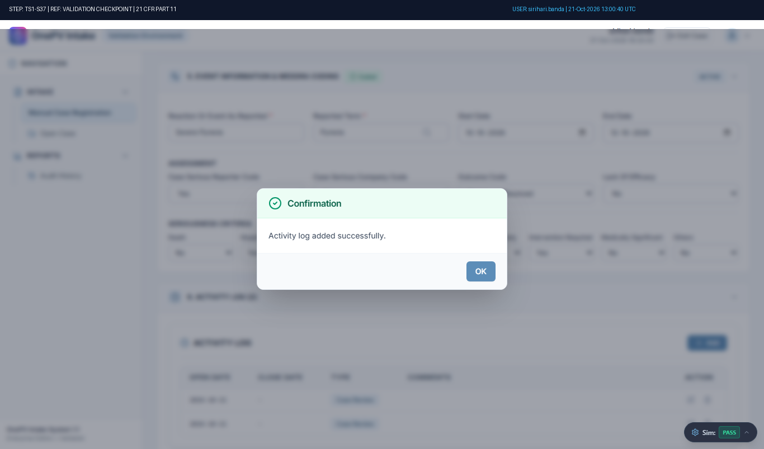
Figure: Audit-Stamped Evidence for TS1-S37 (Ref: TMP-CASE-6012)

Step TS1-S38: System shall allow to delete Log detail.
Status: Fail | Observed: Discrepancy: Negative Test Discrepancy: Expected validation error was not displayed by the system. [Reviewer Acknowledged: Continued test execution]
Procedure: Under activity log, click on the Delete icon.
(Refer expected result 1)
Enter the Reason for delete and click on Delete button.
(Refer expected result 2)
(((µ)))
Click on Save button and click on OK button....
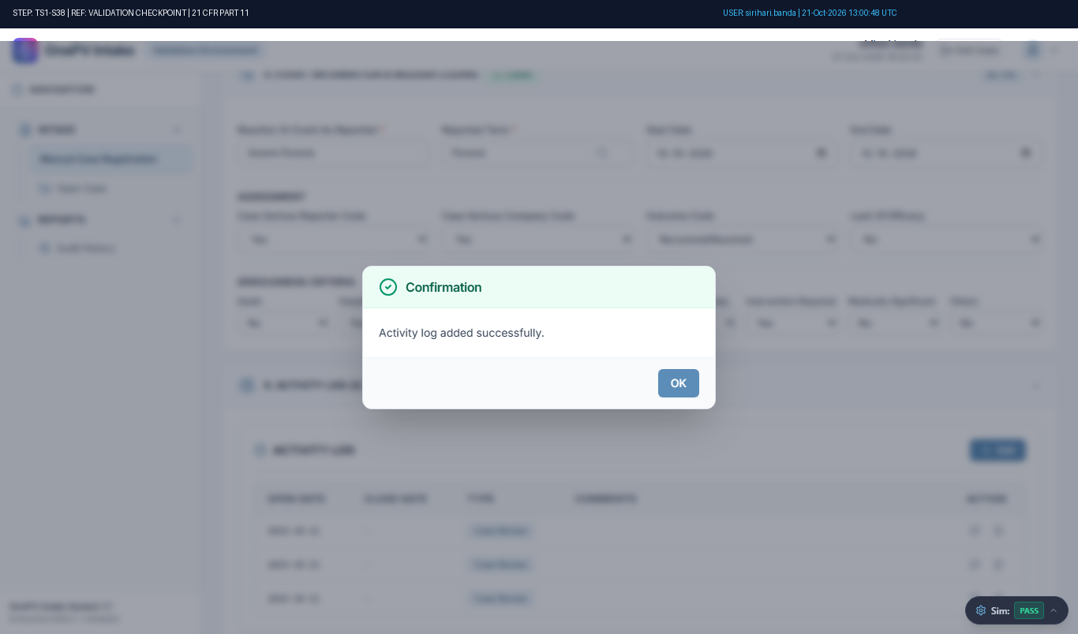
Figure: Audit-Stamped Evidence for TS1-S38 (Ref: TMP-CASE-6012)

Step TS1-S39: System shall allow to Submit case.
Status: Pass | Observed: Case submitted successfully. Official Case Number: CASE-2026-002 generated.
Procedure: Click on Save and Submit button.
(Refer expected result 1)
Click on Yes from the pop-up.
(Refer expected result 2)
(((µ)))...
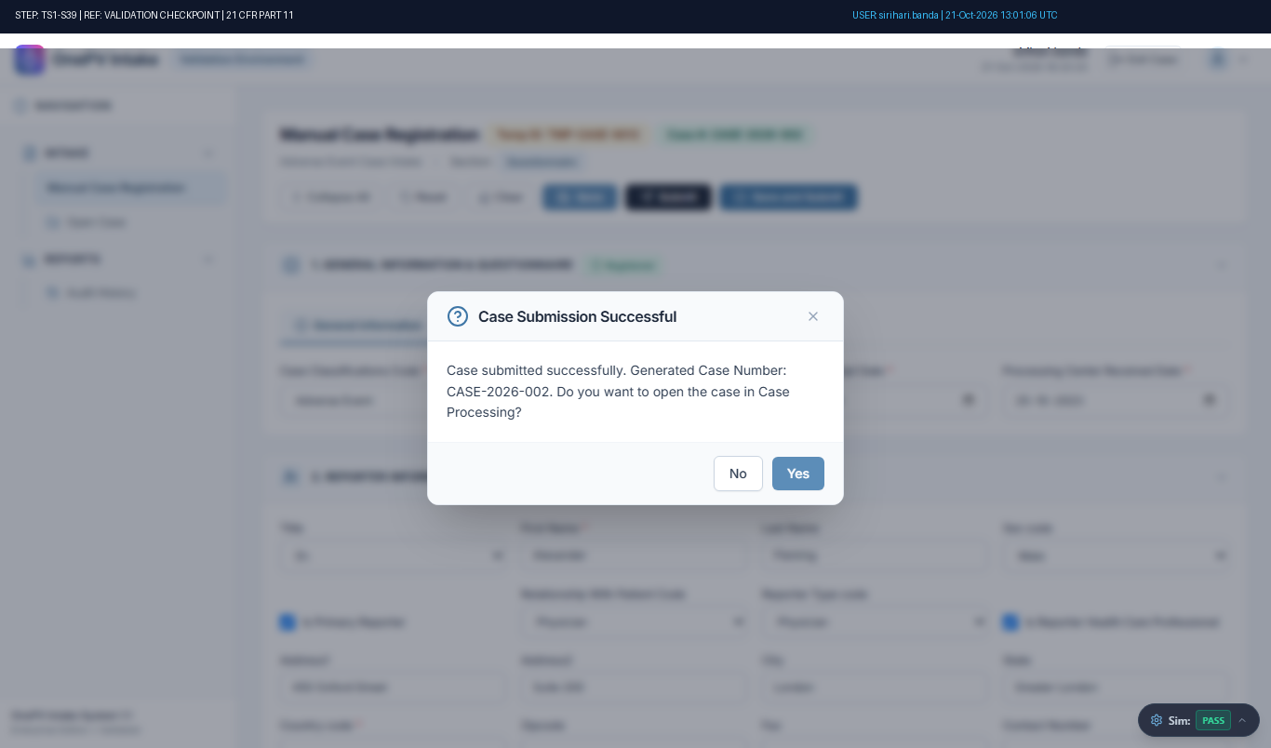
Figure: Audit-Stamped Evidence for TS1-S39 (Ref: TMP-CASE-6012)

Step TS1-S40: Verifying Meddra Code of Event Information in Case Processing page.
Status: Pass | Observed: MedDRA Code data verified in Case Processing page.
Procedure: Navigate to Event Information, verify the Reported term by mouse hovering on right mark.
(Refer expected result)
(((µ)))...
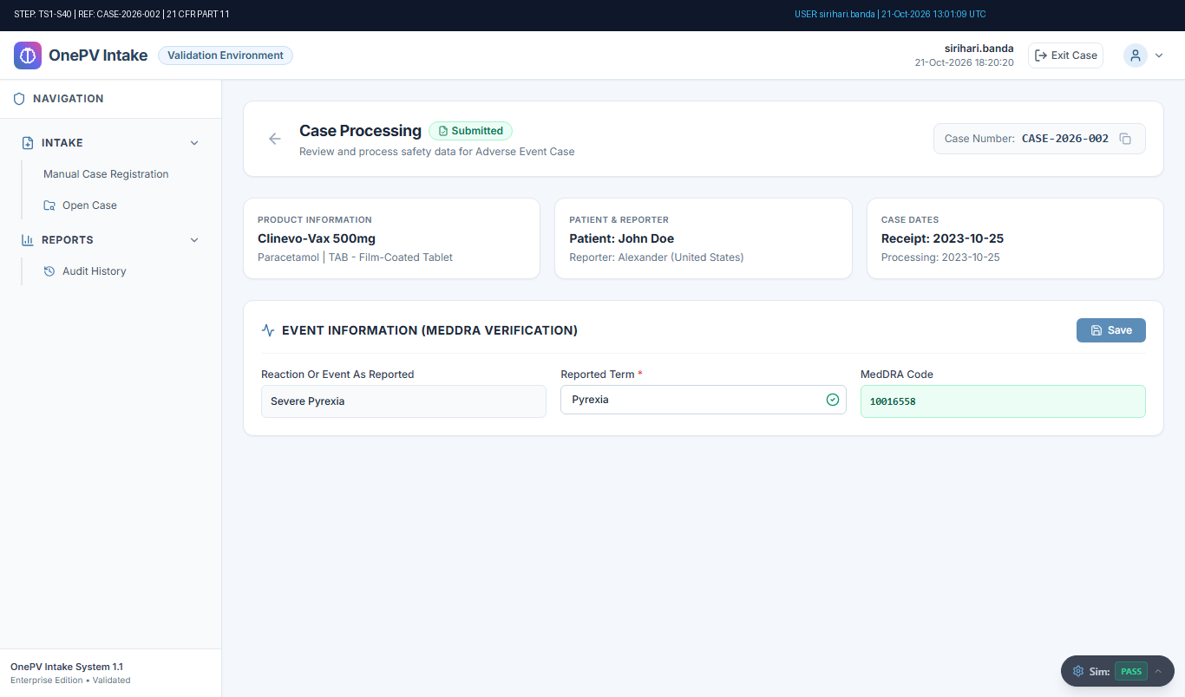
Figure: Audit-Stamped Evidence for TS1-S40 (Ref: TMP-CASE-6012)

Step TS1-S41: System shall allow to Exit from the case processing.
Status: Pass | Observed: User successfully exited from case to Case Intake Search.
Procedure: From the Adverse Event case processing page, click on exit icon from top menu.
Click on YES from pop-up.
(Refer expected result)
(((µ)))...
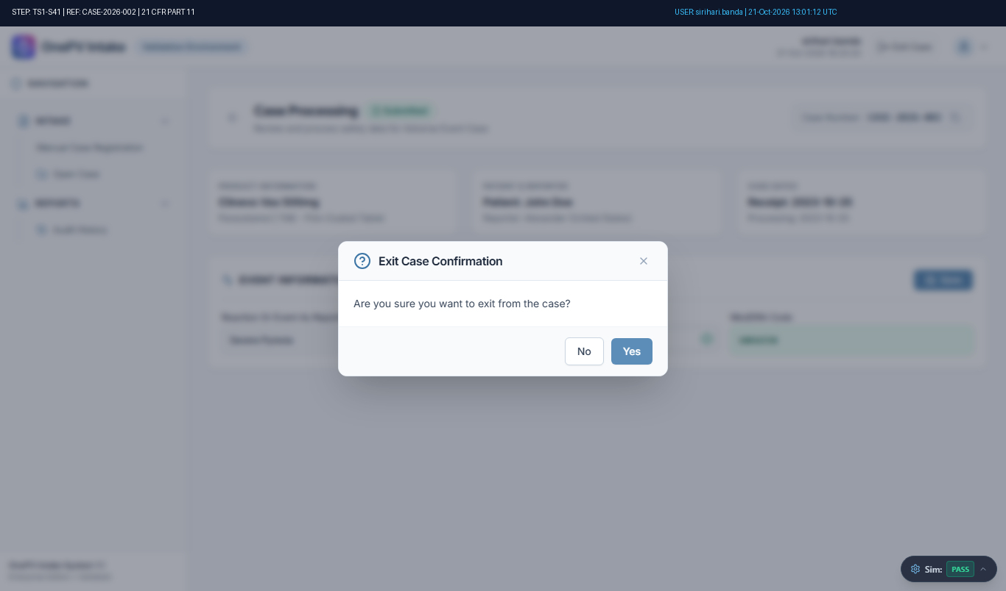
Figure: Audit-Stamped Evidence for TS1-S41 (Ref: TMP-CASE-6012)

Step TS1-S42: System shall allow to Logout.
Status: Pass | Observed: User successfully logged out. Login page displayed.
Procedure: From the Case intake search page, click on the user profile icon.
Click on the Logout button.
Click on Yes from the confirmation pop-up.
(Refer expected result)
(((µ)))...
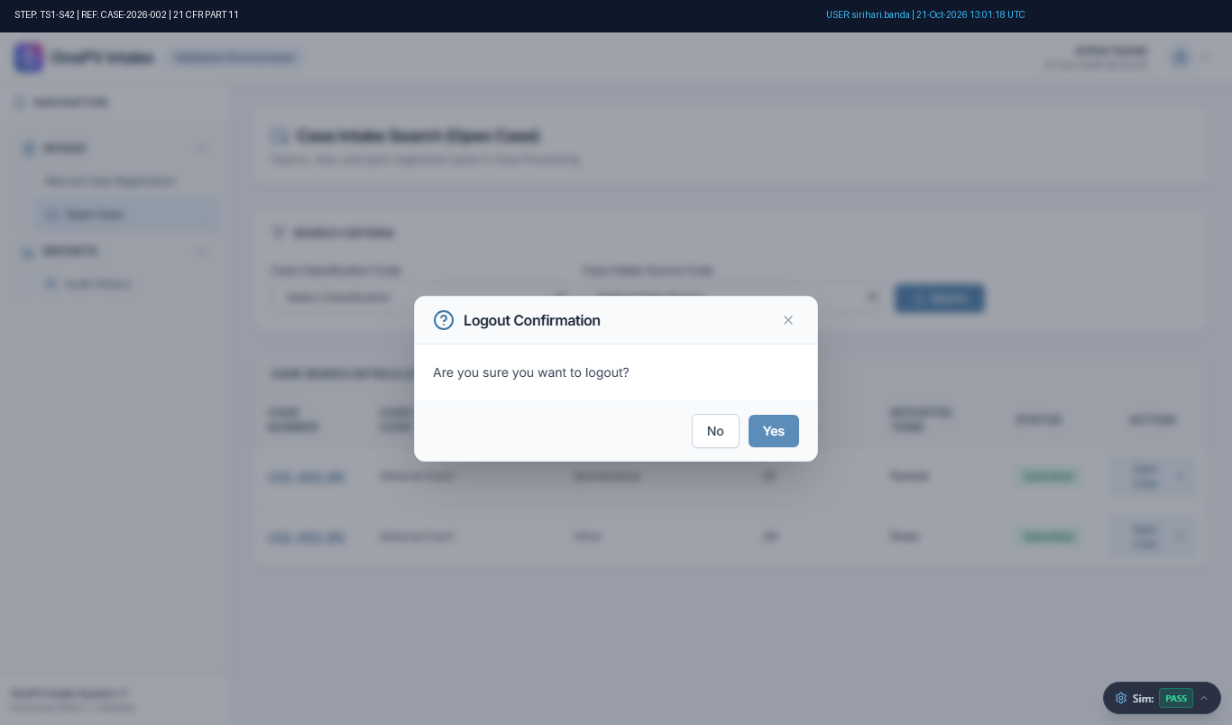
Figure: Audit-Stamped Evidence for TS1-S42 (Ref: TMP-CASE-6012)

Step TS2-S01: Accessing into Clinevo OnePV Intake Validation Environment.
Status: Pass | Observed: Login page displayed successfully.
Procedure: Open Browser.
Enter the validation URL
URL: https://val.one-aipv.com/login
Click on Enter (Keyboard operation).
(refer expected result)
(((µ)))...
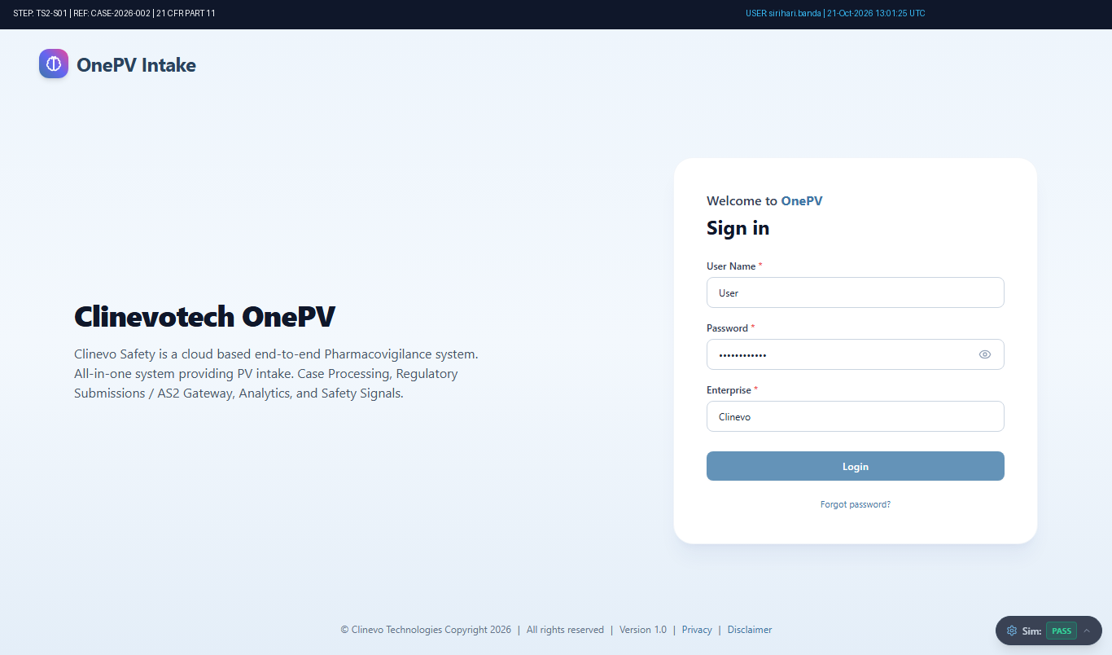
Figure: Audit-Stamped Evidence for TS2-S01 (Ref: TMP-CASE-6012)

Step TS2-S02: Login to OnePV Intake system
Status: Pass | Observed: Logged in as sirihari.banda. Header username and timestamp verified.
Procedure: Enter the following details in Login Page
User Name:
(Enter user name in text field)
Password:
(Enter the password)
Note: Enter the valid password for the user account at the runtime. User entered password at the runtime will be masked for security...
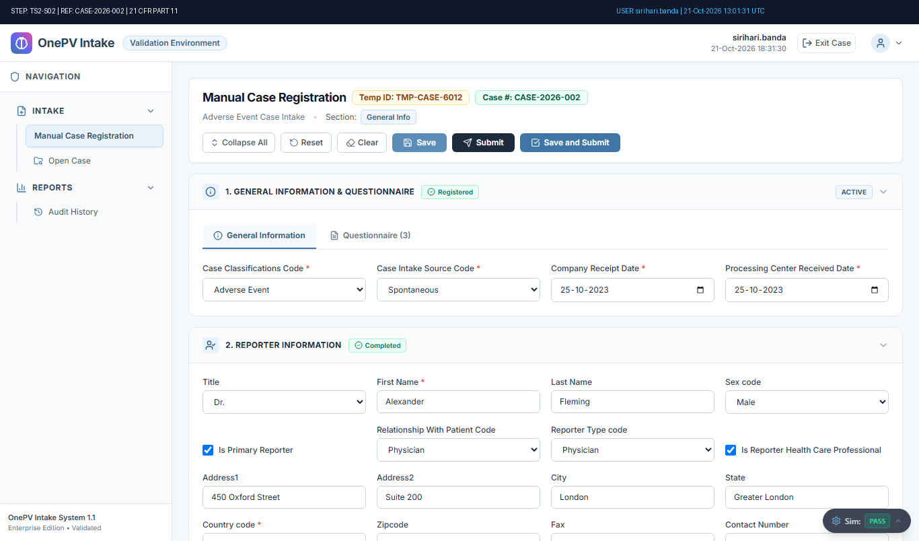
Figure: Audit-Stamped Evidence for TS2-S02 (Ref: TMP-CASE-6012)

Step TS2-S03: System shall allow to navigate to case processing page.
Status: Pass | Observed: MedDRA Code data verified in Case Processing page.
Procedure: From the left menu of homepage, click on Intake and click on Open Case.
In the Case Intake Search, select the Code from below fields,
Case Classification Code:
(Select code from dropdown)
Case Intake Source Code:
(Select code from dropdown)
(Sel...
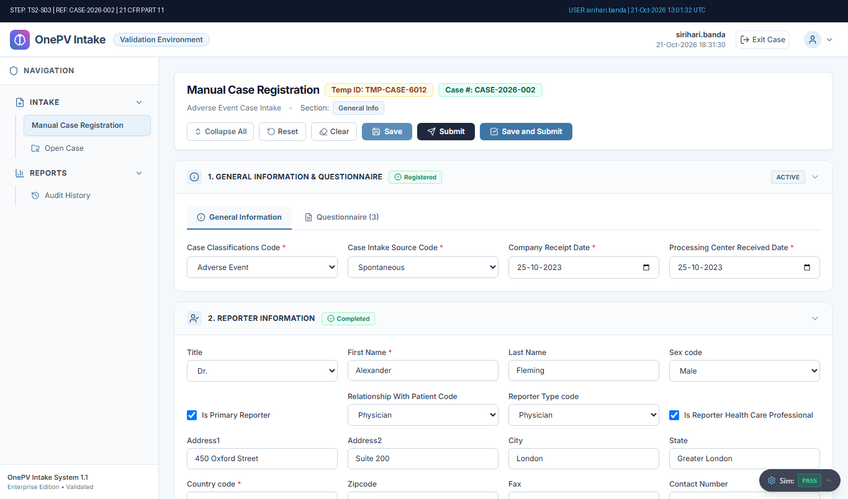
Figure: Audit-Stamped Evidence for TS2-S03 (Ref: TMP-CASE-6012)

Step TS2-S04: System shall allow to update the Reported Term Field.
Status: Pass | Observed: User successfully exited from case to Case Intake Search.
Procedure: In the Case Processing page, expand the Event Information section and Update the Reported term field.
Click on the Save button.
(refer expected result)
(((µ)))
Click on OK button from confirmation message.
Click on Case exit icon from top menu and ...
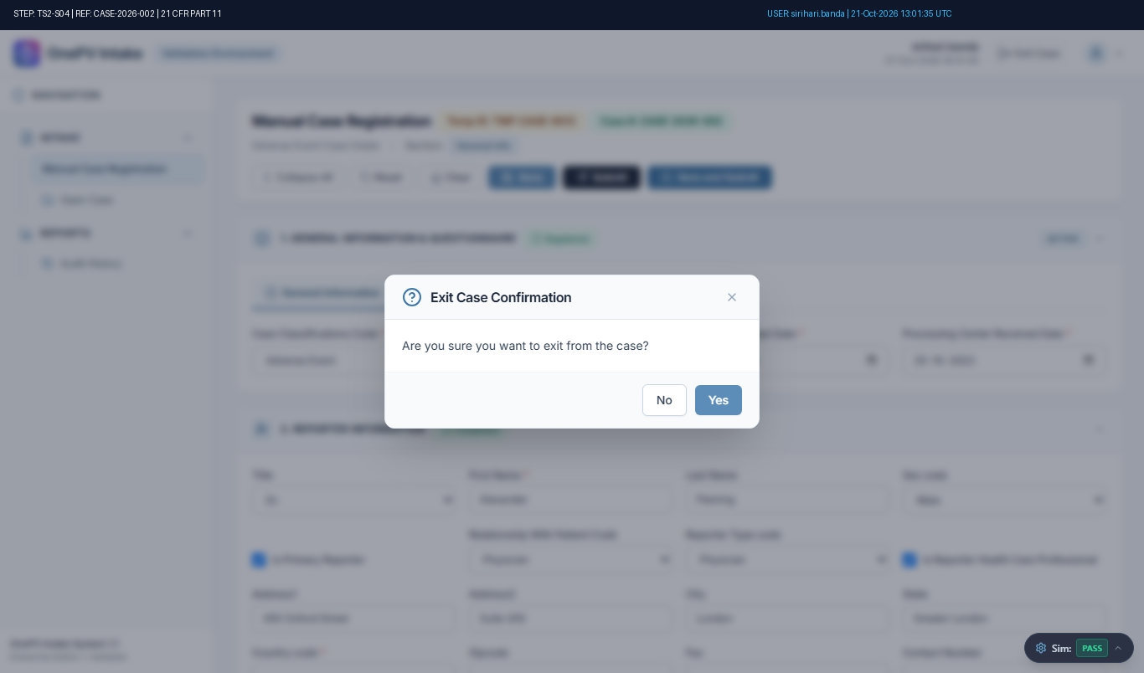
Figure: Audit-Stamped Evidence for TS2-S04 (Ref: TMP-CASE-6012)

Step TS2-S05: System shall display the audit history for the Reported Term field.
Status: Pass | Observed: Audit History records displayed and verified for reported term.
Procedure: From the left menu, click on Reports and click on Audit History.
(refer expected result 1)
In the audit history search page, enter Case Number and click on Search button.
(refer expected result 2)
In the Search Result grid, search the Reported Ter...
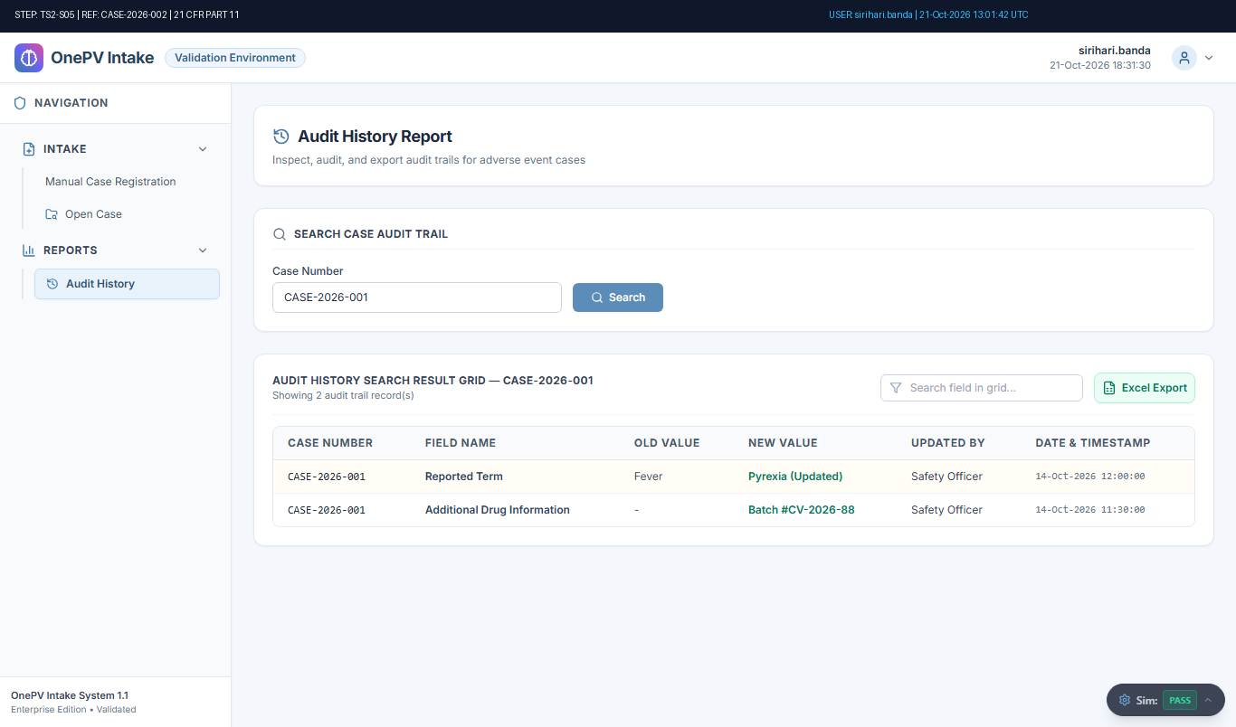
Figure: Audit-Stamped Evidence for TS2-S05 (Ref: TMP-CASE-6012)

Step TS2-S06: System shall allow to export the Audit History in Excel file.
Status: Pass | Observed: Audit History exported to Excel successfully.
Procedure: Under Audit History Search Result grid, click on Excel icon.
(refer expected result)
(((µ)))...
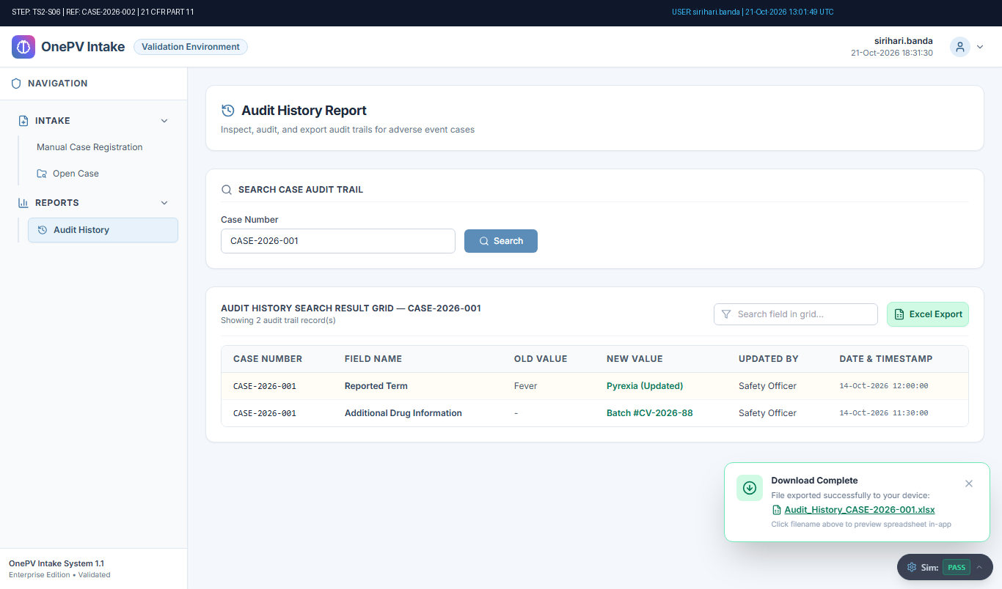
Figure: Audit-Stamped Evidence for TS2-S06 (Ref: TMP-CASE-6012)

Step TS2-S07: Verify Reported Term in Excel file.
Status: Pass | Observed: Executed step action: GENERIC_ACTION
Procedure: In the download pop-up, click on the Excel file and Verify the Reported Term.
(refer expected result)
(((µ)))
Close the Excel File....
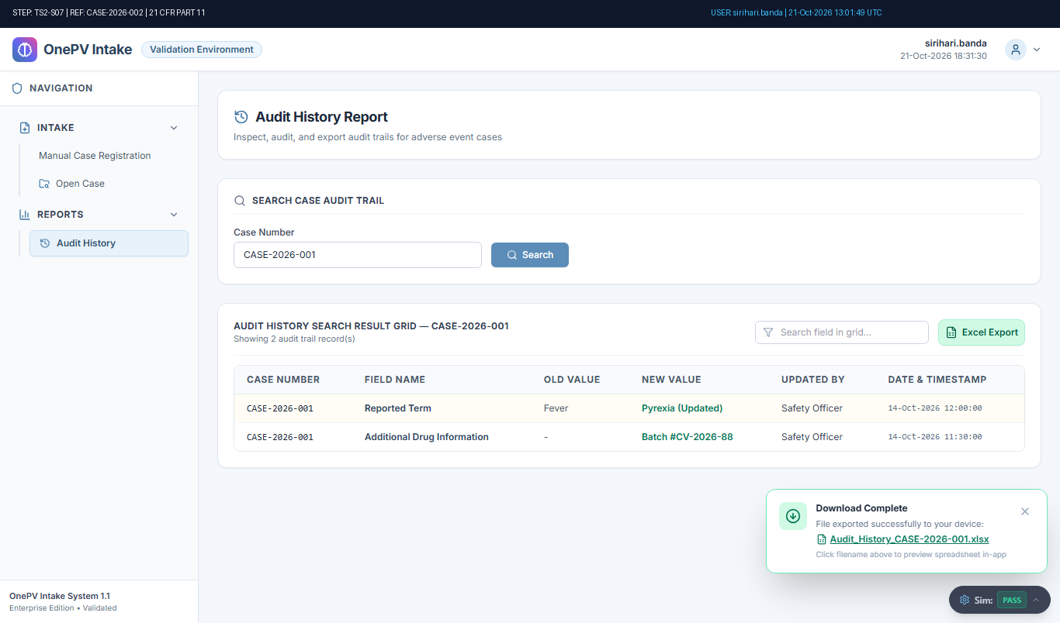
Figure: Audit-Stamped Evidence for TS2-S07 (Ref: TMP-CASE-6012)

Step TS2-S08: System shall allow to Log out.
Status: Pass | Observed: User successfully logged out. Login page displayed.
Procedure: From the Audit History page, click on the user profile icon.
Click on the Logout button.
Click on Yes from the confirmation pop-up.
(refer expected result)
(((µ)))...
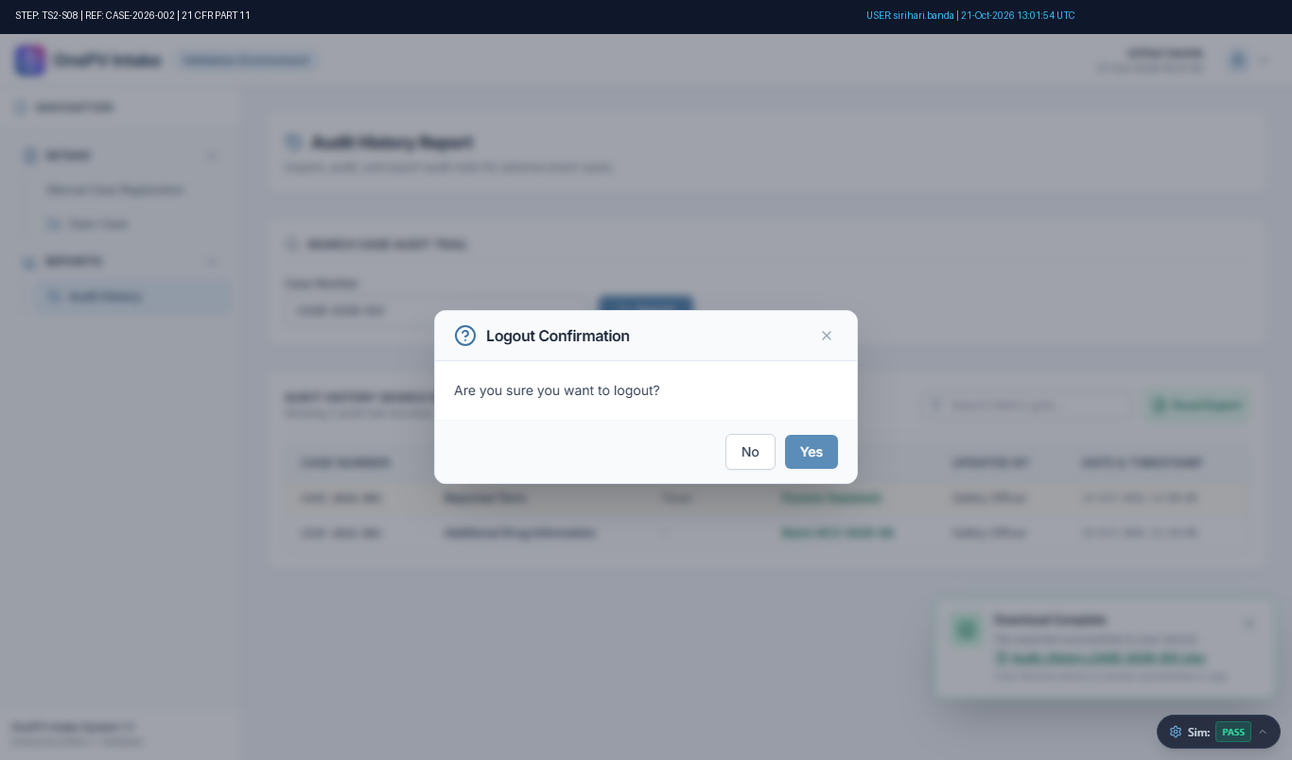
Figure: Audit-Stamped Evidence for TS2-S08 (Ref: TMP-CASE-6012)

